 

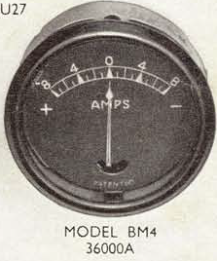



I’ve shown larger copies above and the full illustration below – extracted from my Lucas Ammeters leaflet (no date)and listed as their Catalogue No. 716A

Here is the key to the codes numbers. The main difference being the diameter.

