Dominator Engine & Gearbox Tools

A few specialist tools will make dismantling these components a much easier and consequently quicker task. Get hold of them by borrowing if you can but buy them if you are planning to do several engine rebuilds. However, it is possible to do most of the jobs with improvised versions but these will take time to construct.
See later text and photos for details.
If you have lots of spare cash lying about then an adjustable bike stand will save your back for riding (or pushing) days. If you have a garage with a strong point on the ceiling then fix a pulley system up there. It makes removing and replacing the cylinder head and barrel a less stressful experience. Likewise, fixing pistons to conrods and pushrods into respective rocker cups is so much easier. Especially if no one else is around to help at these critical moments.

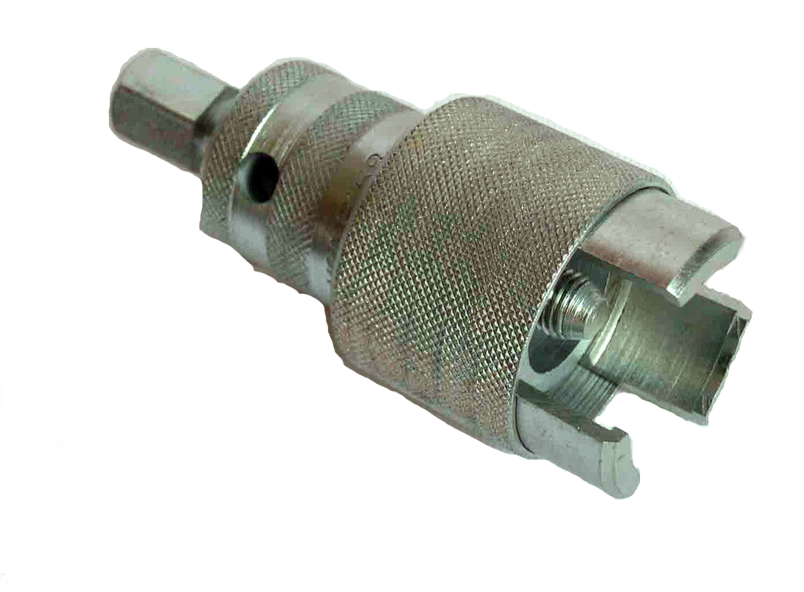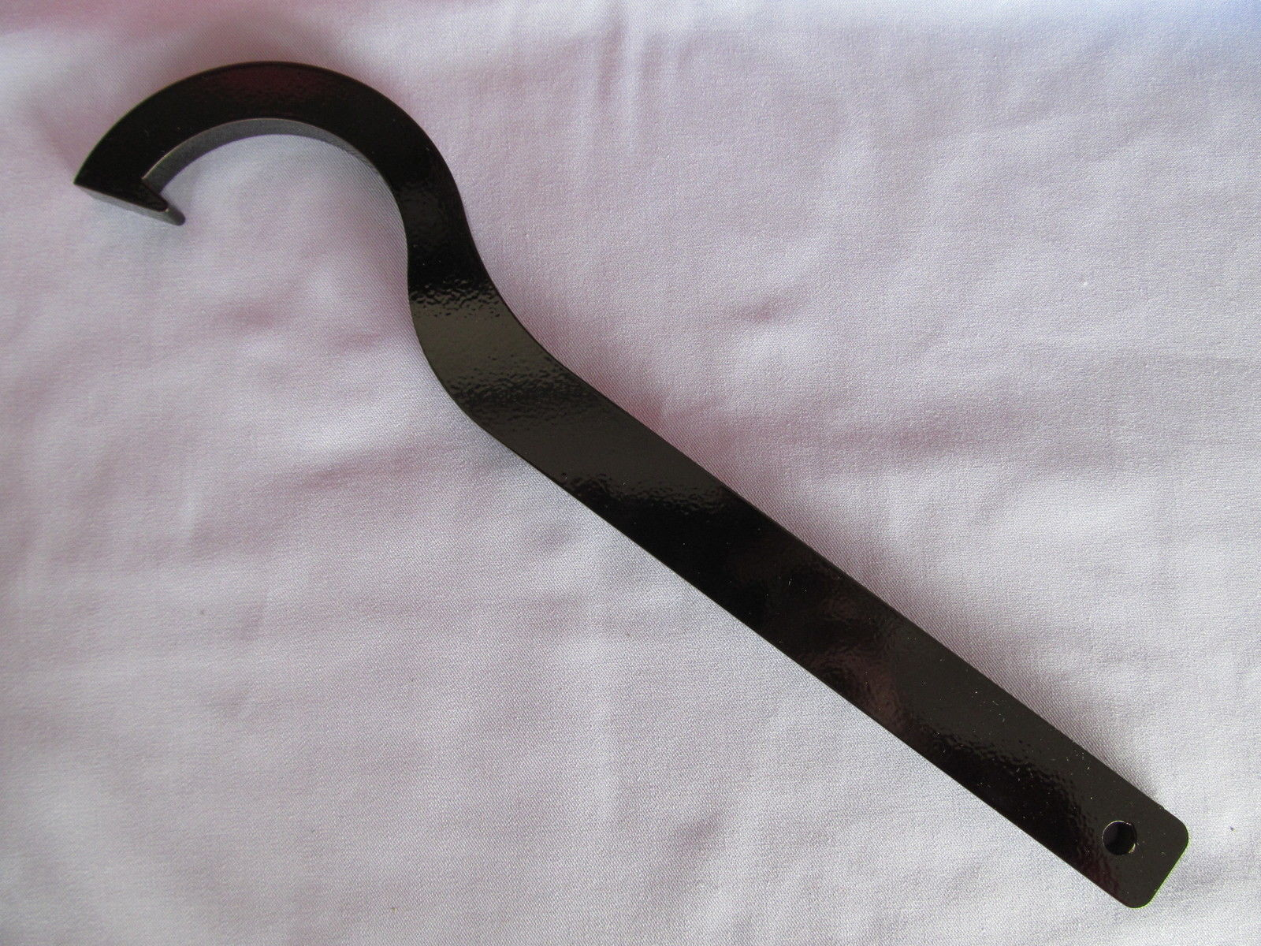
A gas torch for serious heating and an electric paint stripping gun for warming are both handy aids for dismantling chunks that won’t come apart with normal spanner-work and gentle tapping. Certainly, for the likes of engine sprockets and timing pinions a quick blast of heat can cut minutes of removal effort down to just seconds.

Recommended special tools for engine and gearbox work
Main Bearing Extractor
Exhaust Nut C spanner
Clutch Locking Plate
Timing Pinion Extractor
Clutch Extractor (this also doubles up as a gearbox main-shaft extractor)
Engine Sprocket Extractor
Camshaft Sprocket Extractor
Box Set of Narrow Wall Sockets – If you can find a one, the King Dick 3/8” drive set from the 1950 & 60s are ideal for the Norton engine. These have thin, parallel shoulders which make them ideal for getting at the recessed head bolts.
A set of Bedford ring spanners and Geodore flat spanners ¼” to ½” BSF/WW
Tap & Die Sets to help clean all the BSC,BSF & WW threads.
Releasing Oil
Bottle of unwanted Cola drink.

The above will generally help to get the engine out of the bike and into big chunks.
For those people who wish to go a bit farther then a valve guide extractor, rocker extractor, valve spring compressor, Adjustable Peg and Lock-ring Spanners will be necessary for the wheels and gearbox. Both of these tools can be homemade from a flat bar and masonry nails.

Although having the tools mentioned above will generally help to get an engine dismantled and rebuilt more easily, they can, to a large extent, often be substituted with other means. The NOC WebSite Forums have plenty of suggestions as to alternative ways and means of getting stubborn engine chunks apart.
For example, a simple form of the fairly expensive pinion extractor illustrated at the beginning of this chapter can be fabricated from 3 Coach bolts, a triangular metal plate, a nut, matching thread bolt and a Jubilee Clip.
The useful clutch-locking tool shown below can be homemade from spare parts often found in the garage or shed junk box.

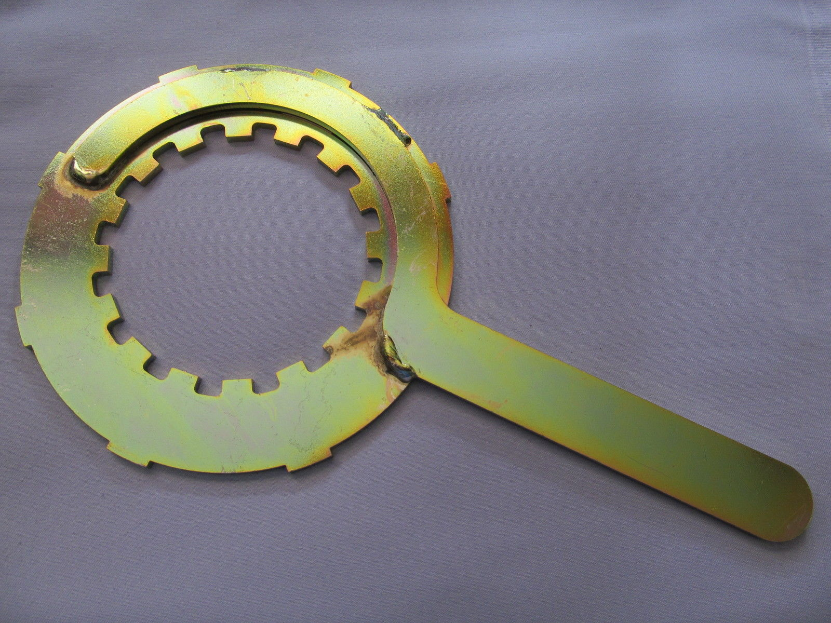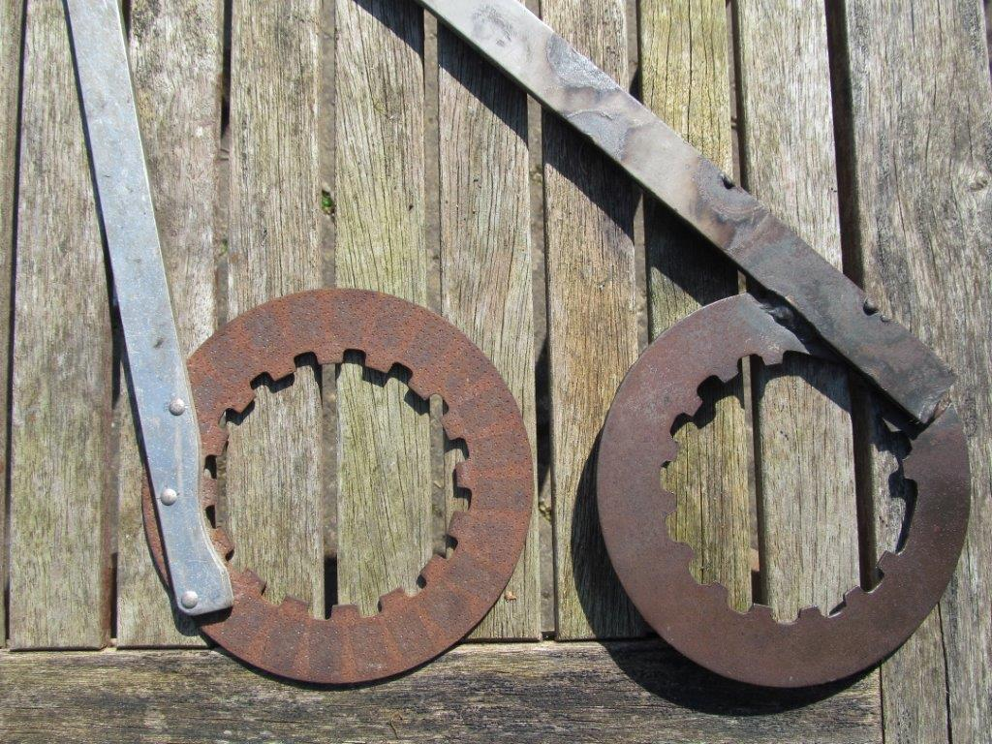

This can be replicated out of some old clutch plates and a flat bar bolted to one side. When being used, a piece of tubing such as an old fork stanchion can be slipped over the end to extend the handle down to the floor and so leave two hand free for the torquing spanner.
The suggestion of a bottle of Cola may seem amusing but this drink has a good reputation for dissolving the rust between stuck metal parts. It generally needs a good 24 and sometimes 48 hour soaking to be effective but has helped to release many seized pistons over the years.



