Dominator Frames
The Model 7 basically used the ES2 frame produced by the factory at the time. This initially had plunger style rear suspension. By 1952, this had been superseded by the simpler pivoted swinging arm system which became the norm from then on. The exception being a batch of rigid rear end frames produced almost exclusively for the export market between 1950 and 1952. This being the 500cc engined Model 77. This bike wore the frame model number 13 which was also applied to the Model 50 Single. Adding to the confusion, the Model 77 title was revived in 1957, powered by the 600cc engine. This machine, however, used a derivative of the Model 7 swinging arm frame.

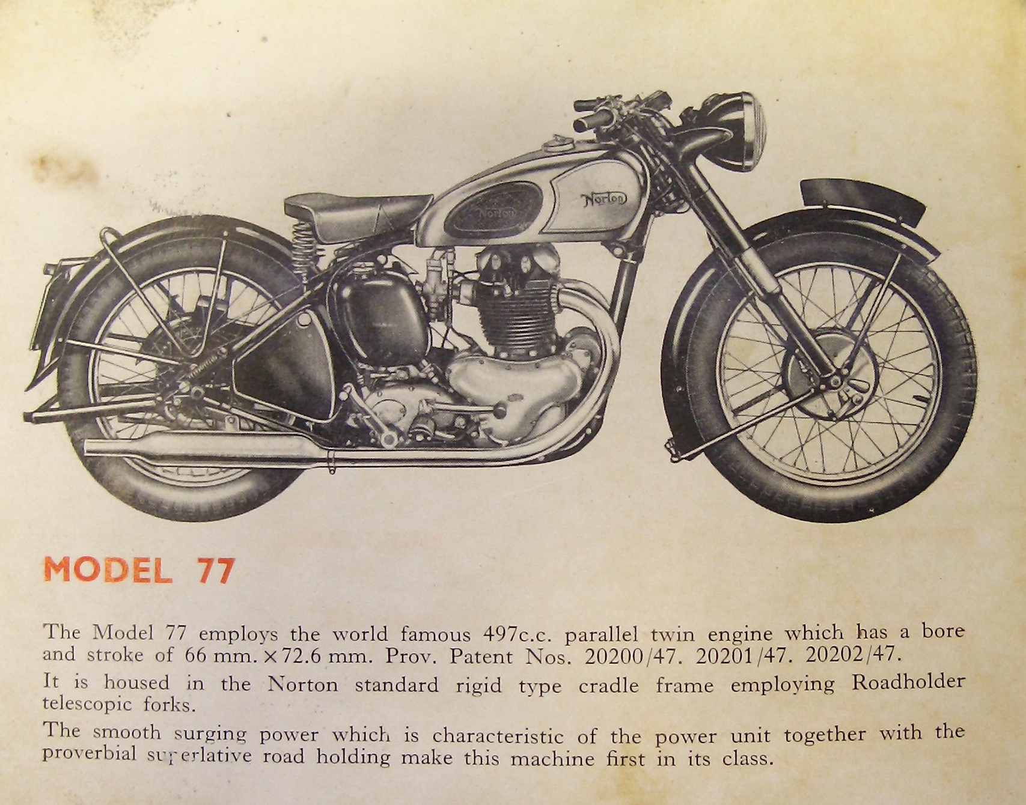

The single downtube frame continued to be produced, by Nortons, and next found a new Dominator home as part of the competitive Nomad series of machines. So prolonging the life of this heavy lugged frame until 1960.
The problem that restorers have tended to find is that, typically of Norton, the single downtube frames made for the various models are not readily interchangeable.

The Featherbed
Rex and Cromie McCandless developed, along with Artie Bell, a racing frame that was to turn into a world beater. A new welding process had become available which was about to revolutionise motorcycle frame building. This being phosphor bronze welding, a process that allowed the making of lighter frame construction to actually succeed. The McCandless' brothers took their frame along to Nortons, for appraisal. They were impressed enough to purchase the manufacturing rights. However, after producing a batch of frames for their racing team, they headed off to Reynolds Tubes, who from then on manufactured the featherbed frame until 1970. The frames were produced first in 531 tubing with Phosphor-Bronze welding for the Manx singles. Then in 1952, the road bikes frames were arc-welded and made from 'B' grade solid-drawn tube. While bronze welded 'A' grade solid-drawn tubing was used for the International frames
The title 'Featherbed' was never an official one but dubbed by Harold Daniell in appreciation of a comfortable ride.
A difference in the road going 'Featherbed' that was noticeable from its Manx brother was the inclusion of a gusset plate or trouser plate beneath the head stock to cure head 'nodding' when bumped up kerbs, an occurrence not normal for a Manx! The Manx also had a strong or head steady plate assembly, which tied the top of the steering head to the top cam box. On the road frame, the trouser plate was arc welded on, then at the bottom a weld 'puddle' was done by a gas torch to help relieve the stresses.
The rear subframe was bolted onto the main frame up to 1954, but from 1955 was made of heavier gauge tubing and welded on. The loop (beneath the seat) had a sharper radius in 1956. This was to accommodate a matched looking pair of oil tank and battery box.
Another distinction between Manx and road, was the inclusion of a seat frame loop extending beneath the seat on the Manx quite solid and straight on the International 'drooping' down to affix the rear mudguard, while on the road Dominator, absent. The later Manx having a shorter loop that contoured the rear of the seat.
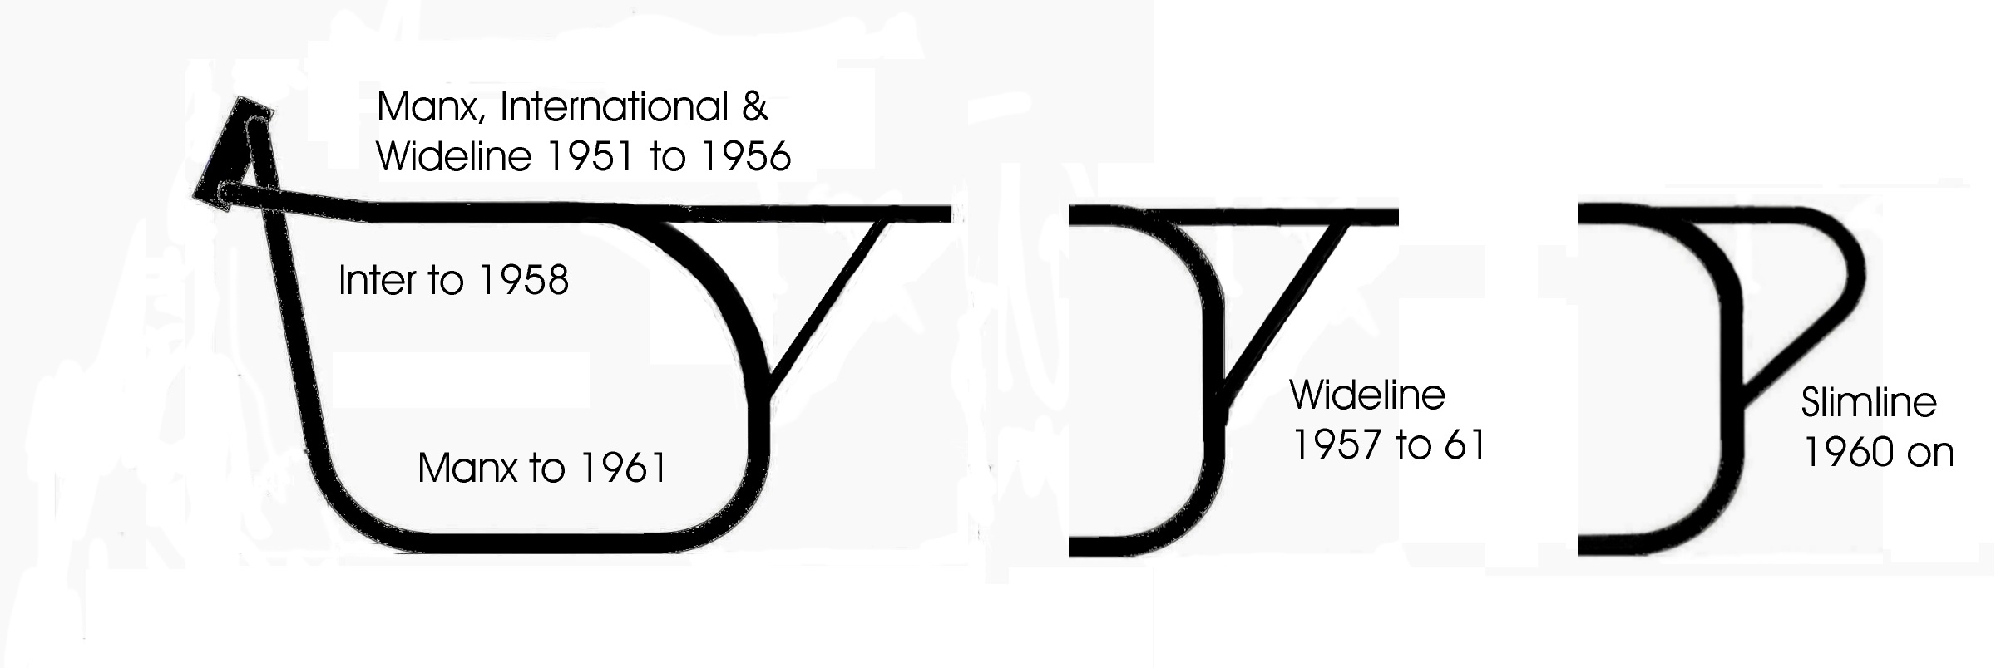
One feature unique to the ‘singles’ frame was a flattened section on the inside, top right hand frame tube (wide and slim); this indent being for the cam box or to allow tappet cover removal. One other point is the spacing of the two front engine plate lugs which were of a narrower spacing for the pushrod and side valve engines i.e. 2 1/4" front crank case as opposed to 3 5/16" for Manx, Inters, and all Twins. If you must fit a twin into such a frame, a couple of spacers on longer bolts will be required.
1960 saw the change to the Slimline version of the Featherbed. The top tubes between the rider’s legs were narrowed, making the front of the top tubes slightly wider. This led to changes in the seat shape and mounting and also the mounting points for the oil tank and battery box.
Seat fixings are ostensibly non-interchangeable. The wide-line having bolts captive in the seat hanging through two holes in a flat bar across the frame. The seat being secured by wing nuts. Also each one having one of the largest of the many 5/16" hole plain washers which pre-loaded it against the double-flanged grommets fitted in the frame bar.
The Slimline seat fitted on to two rearward facing spikes on the frame and attached to the rear mudguard via a Dzus fastener.
The 1956 to 59 and 1960 on oil tanks and battery boxes look identical but both have differing mounting points and brackets to match. It is possible to add small brackets to make early items fit later frames and vice versa. This is not so easy with the de-luxe oil tank due to its extended filler neck.
The Slimline also had a pair of lugs to pick up the bottom of the small front engine late, on the Twins but not on the 'singles'. From 1964 on, those lugs were inverted by Reynolds Tubes (Ken Sprayson suggestion) to stop the Atlas engine breaking the frame.
In 1964 the frame bracing tube above the swinging arm pivot that takes the front of the rear mudguard had its stud removed and was welded in place.

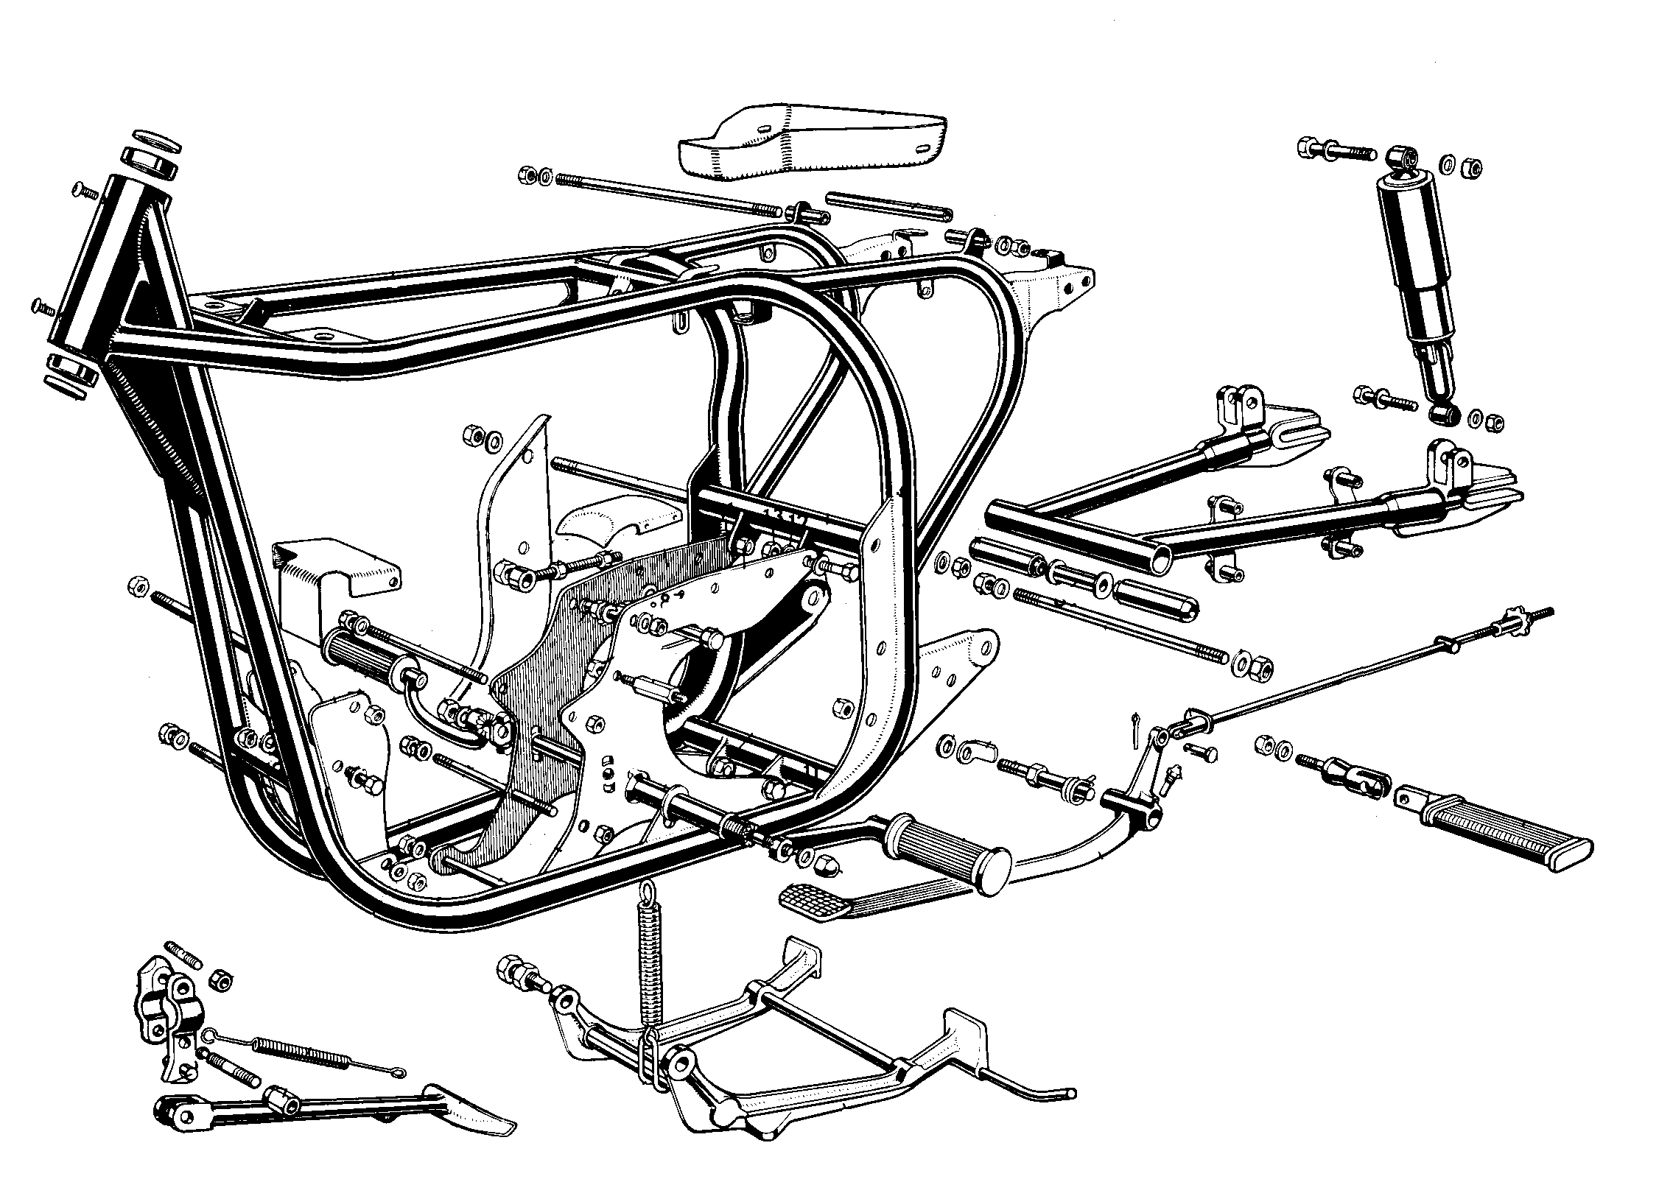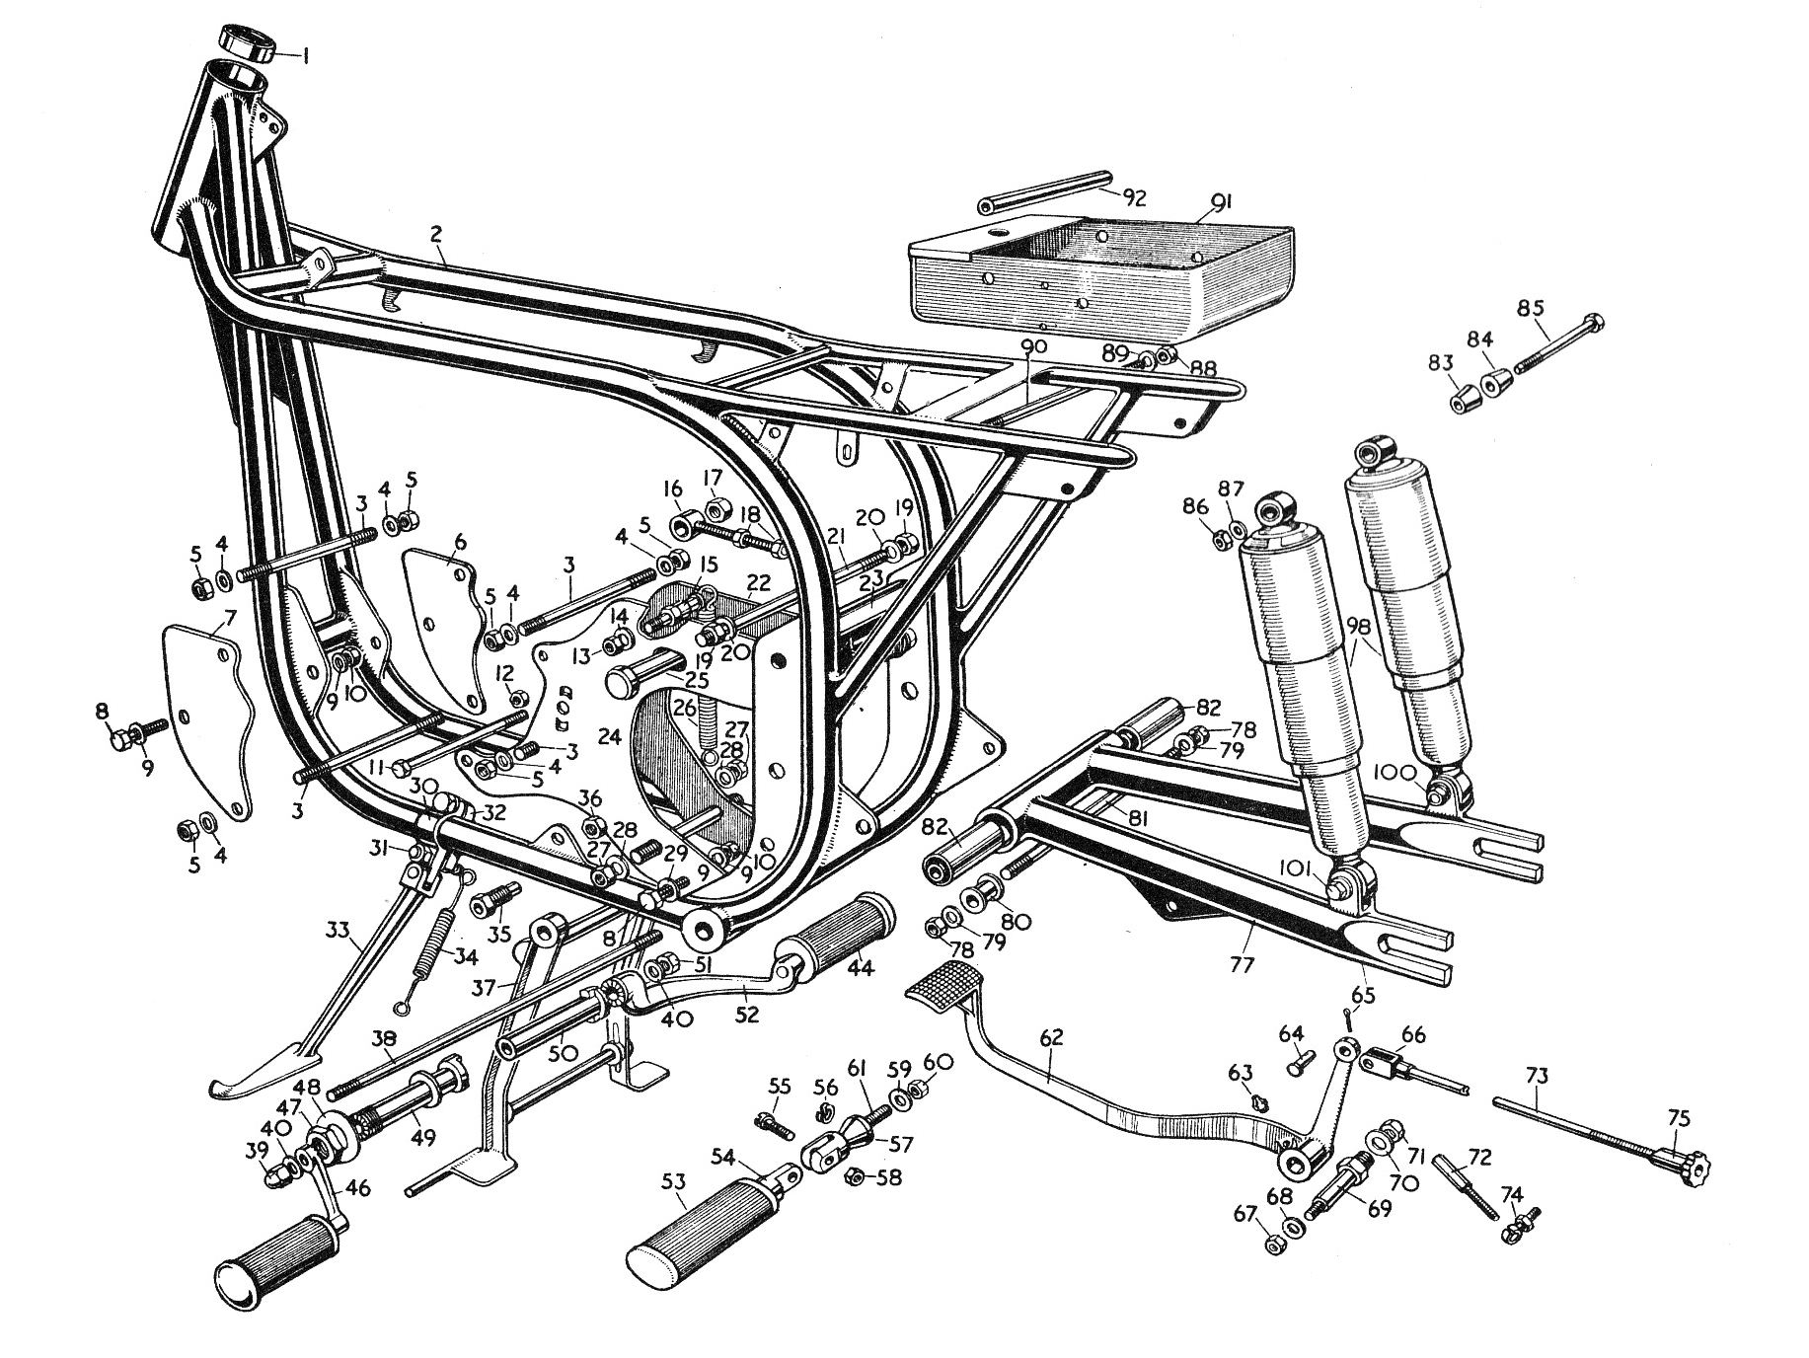

Restoration & Running Notes
One other significant change on the Slimline frame was a shorter rear damper length,
All Slimline models had an extended damper unit length of 11.9”. The top bush was 3/8” and the bottom 5/16”.
All the Widelines, from 1957 to 60, both Singles and Twins had an extended damper length of 12.9 " with a bush assembly top and bottom for 5/16 bolts.
The tool tray under the seat was altered to allow for the vapour tower on the oil tank, which came in late 1962 and also the oil filler on the de luxe 1960. It being under the seat, inboard of the frame, (a Wideline tool tray is oblong in shape, whereas the Slimline has a slightly triangular shape.) The fixing holes are the same, so you can fit a Slimline to a 'wide' but not vice versa. On the Wideline tool tray there is some times a tank strap fixing bolt which has a spring in it, this was introduced in 1959, until then over tightening of the tank strap bolt could break the strap. The petrol tanks were obviously different as were the fixings, Slimline by virtue of upward special bolts through washers and rubber bushes, quite fiddly (witness them found in 'far flung' corners of the garage.) The Wideline tank being held by a single strap down the middle with a sprung bolt arrangement through to the front edge of the tool tray.
By 1964, the removable stud bracing the rear assembly beneath the seat on the Slimline was replaced with a welded tube. Similarly, at roughly the same time, the rear engine and gearbox plates mounting tubing, just above the swinging arm pivot was welded to the main tubing; replacing the previous bolted-in place item.
Also in 1964 the steering stops became a plate welded to the gusset plate beneath the steering head. A cowling was also re-introduced and fixed to the steering head with two small screws. Certain cables were covered by this cowling in an attempt to tidy up the mess that now appeared behind the smaller headlamp unit.
Anyone intending to purchase a Wideline or Slimilne frame, with a view to building or restoring a bike, should first carefully check the areas noted in the diagram below. These particular areas are known weak points where either cracking or rusting are likely to occur.
