More Lockdow Labours - Converting a Dominator 99SS into a 99ES*
Part One – The Mechanical Engineering
It all began when I had completed installing a Tony Hayward belt drive and Electrex conversion to my 99SS, fettled to just fit within the standard primary chaincase.
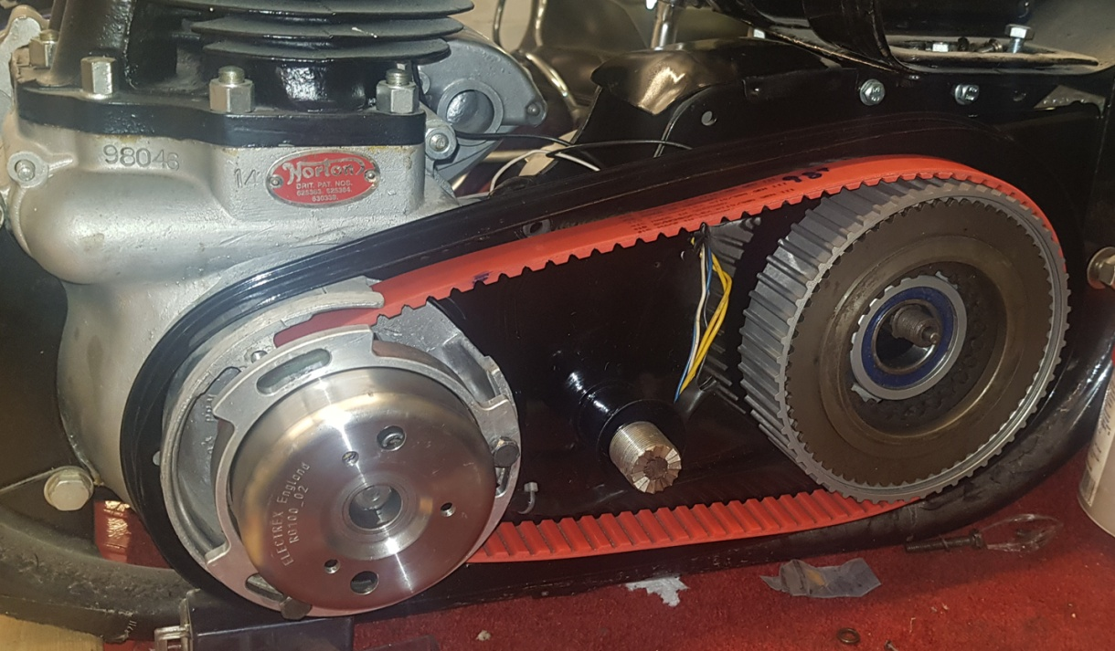

I couldn’t help noticing that there was now a yawning cavity where the distributor used to be. You could achieve a similar result by using a Commando cam and timing cover with points (I guess).
With my knees getting a bit dodgy I started to toy with the idea of an electric start conversion…..
I contacted Alton, and they told me that they didn’t do one for Dommies, and had no plans to do one either, but that they had sold a Commando kit to a guy in England who was attempting to install it on a Dominator. I asked them to put me in touch with him and they ignored the request. Which was annoying.
I researched the Club forums and saw Tony Harris‘s successful drive-side conversion project, and corresponded with him. He tipped me off to the Nippon Denso starters used for Harley Sportsters, and the name of a place where they will machine starter rings to order.
So I wondered if it was possible to start the engine by driving it through the timing side. Tony had warned me that Triumph had tried this on Bonnevilles in 1980-ish, but that their experiment had failed, probably due to stripped teeth on the timing pinions as any lash was brutally taken up. Norton timing gears are made of sterner stuff than Triumph’s of course.
First I estimated at the forces which might imposed by a such a starter, by reverse-engineering what a human can achieve. I had carried out some basic calculations based upon what is happening when an engine is kickstarted normally, to get back to the required torque at the engine pinion, based these fairly heroic assumptions.
As reality check I put a torque wrench on to the mainshaft of my ‘real’ engine, and it turned out to be considerably less than the 40Nm which I had estimated (good).
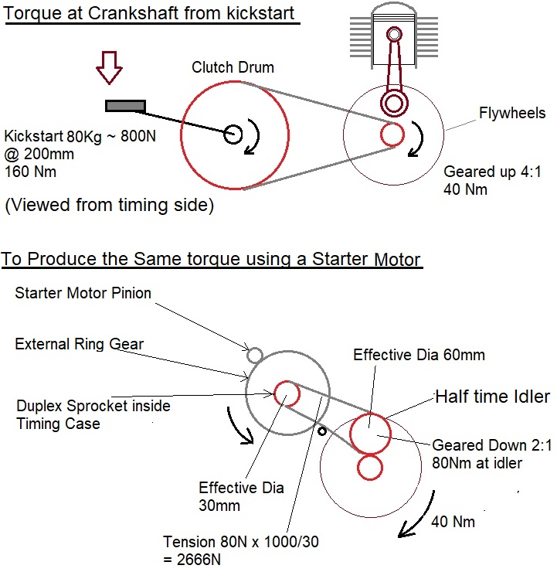
I researched a hell of a lot of alternative types of starter (there are 5 dismantled ones right now on my shelf!), and the Nippon Denso Offset Gear Reduction (‘OGR’) type really does seem to be the best fit between the chaincase and offside engine plate. It really nestles there quite beautifully (see below) after just a bit of extension and cutting away of the engine plates. These 1.4 kW Nippon Denso motors are used on loads and loads of different vehicles, in slightly different variants, up to 2.5 litre petrol Landrovers. I figure that something that can start a 2.5l engines shouldn’t really struggle with a 600c low compression twin.
OGR starters have internal gear reduction, and have a further stage of reduction when their small pinion engages with the starter ring on the flywheel. Geometrically it is only possible to have a starter ring of about half the size of the Harley’s in the location of the distributor, but this is compensated for by a 2:1 reduction in the chain drive. Sadly that is then cancelled out by the 1:2 step-up from the half-time pinion to the mainshaft pinion.
I wanted a solution which made minimal impact on the Dommie’s appearance, with the least possible (and reversible) modifications to the standard parts (except for engine plates and timing covers which I had decided would have to be sacrificed for the greater good).
Now a conventional series wound DC starter like the Nippon Denso 1.4kW OGR type is intended to be a brutal thing, and it certainly is when operated in the usual ON/OFF mode. ….and yet here the task in hand is usually accomplished using only intermittent one-human-leg-power, and that being applied only for about 1 second. There is a big contrast between bicycle components and massive chunky starter gears though.
I figured that by using some robotic technology, it should be possible to emulate the conventional technique of
  - Easing the pistons up to near TDC, waiting 5 seconds and then
  - Ramping up the torque gently to take up backlash in the timing gears before:
  - Applying just enough full torque to get over the next TDC. Then ramping up the speed continually. That would require a position sensor, and possibly torque and rotational speed sensors. And a single board computer to implement the logic.
The power electronics and computers required to achieve this were simply not available to Triumph 40 years ago.
I also do not know what capability sprag clutch bearings had 40 years ago either, but maybe capable ones were not around at that time either. All modern motorcycle designs use them, and they are very elegant things. Not used on Harleys though – they work like cars and have a solenoid to pre-engage the starter pinion with a starter ring on the flywheel before the starter motor proper kicks in.
I quickly decided that I did not want to work on my original engine, and that I would need to build up a test engine for proof-of-concept development purposes. I decided to test it in three stages,
  - Spinning the crankshaft only (with lead balancing on the crankpins) – this can be done by hand
  - Spinning crankshaft, barrels, con-rods and pistons – a bit tougher
  - Spinning crankshaft, barrels, con-rods, pistons and cylinder head (the real test against compression)
I figured that as a benchmark two hundred trouble-free starts against compression would prove the viability of the concept well enough to put on my road bike.
So I set about buying enough parts to build a ‘99, and it proved to be surprisingly easy. I wanted to build a really “good” engine, so I bought a freshly reground crank from eBay, and a set of barrels from the club. I already had some new +020” NOS Hepolite pistons. Acquiring, re-sleeving and repairing the barrels (a broken fin) came to about £800! And that’s not accounting for the pistons…..
Even though it was going to be a test engine, I didn’t want to have a solution which butchered the crankcases (of course). The plan was to introduce the drive into the timing case through the now disused distributor opening, without imposing any load on that flimsy part of the chaincase.
So I decided that to get the reduction I needed I would drive an external “ring-gear” (located outside the offside engine plate) on a shaft which would come through the middle of the distributor hole and have a small sprocket inside the timing case. The drive would then go on via a chain to the half time pinion, which would have a sprag bearing. I really did not want the chain and starter ring being continually being driven “backwards” at high speed after the engine had started.
I mocked up a set of engine plates in plywood, and the concept started to look just about possible – albeit with only millimetres to spare.
Then I modified some old engine plates to match. Then I welded bits on to them, and ground bits off them, over and over and over again to get the motor in the position just where I wanted it. Then I did it again, and again….
However I used the higher figure when selecting chains and the sprag bearing for safety.
Sprag bearings come in hundreds of different types from dozens of different manufacturers, but sadly only come in a few standard outer sizes. They are a minefield of torque capacities, keyways, axial loads and maximum idling speeds. I bought several, but in the end I had no choice but to go with 25mm inner/52mm outer. That leaves very little meat on the duplex sprocket, if it is going to miss both the oil-pump worm drive and the oil feed to the end of the mainshaft. So the standard 3/8 chain option got binned quickly as being just too bulky. At one point I looked at using 6mm duplex chain, which has just about enough strength, but it looks more like it belongs inside a carriage clock than inside a motorcycle. In the end I went with 8mm duplex, which has plenty of strength for this application, while remaining quite small.
Of course it is vital to maintain the oil path between the oil pump outlet and the quill on the mainshaft, and fortune smiled here. The pump already has a tiny removable insert which can be replaced with an extended version to hold that vital conical rubber seal.
Getting oil to the mainshaft looked somewhat trickier, but when the old oil seal is removed it is fairly easy to make a tubular steel extender to hold a new oil seal - without clashing with the new starter chain (just!).
Cramming all of this into the standard timing cover was always going to be a challenge, and I went for the commando cam drive-chain arrangement, which has the chain inboard next to the crankcases, instead of being outboard of the distributor chain like a Dominator. I acquired, and machined both sprockets off, a standard Dommie “halftime-pinion-and-two-sprockets” intermediate gear. I then brazed on a new 18T sprocket with a somewhat smaller clearance from the pinion than the Commando has - to save a couple of millimetres. Important, so that the chain and cranked tensioner would all be completely inside the stiffener plate.
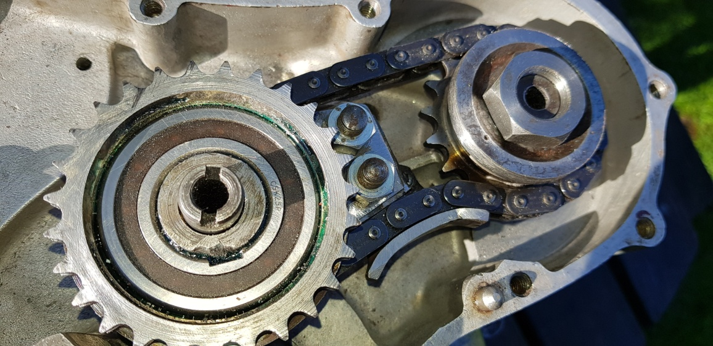
Timing chain and tensioner - all within the plane of the Crankcase.
Normally the timing cover picks up the lightly-loaded end of the half-time pinion spindle, and obviously it was never intended by Norton to have to accept the forces which would be associated with electric starting. I decided that it would be best to redistribute the forces all over the right hand crankcase with a steel plate, and provide a steel spider off that plate to support the end of the shaft. I drew up the plates and had them laser cut.
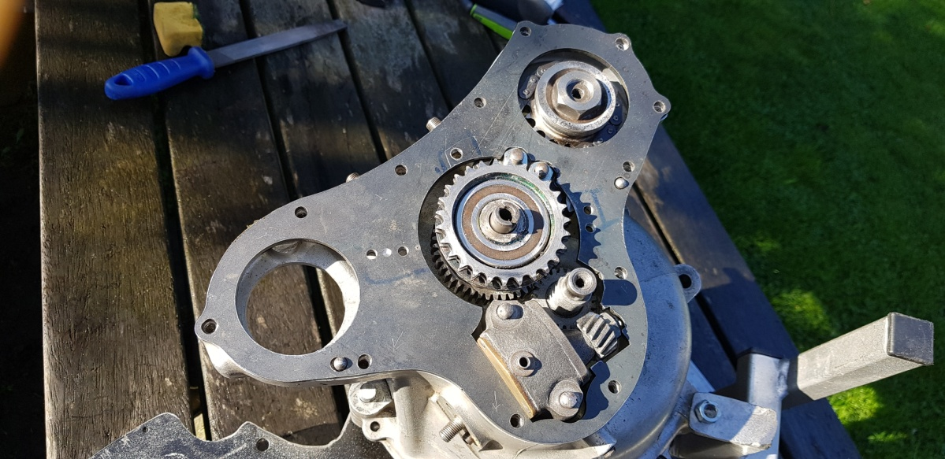
Strengthening plate
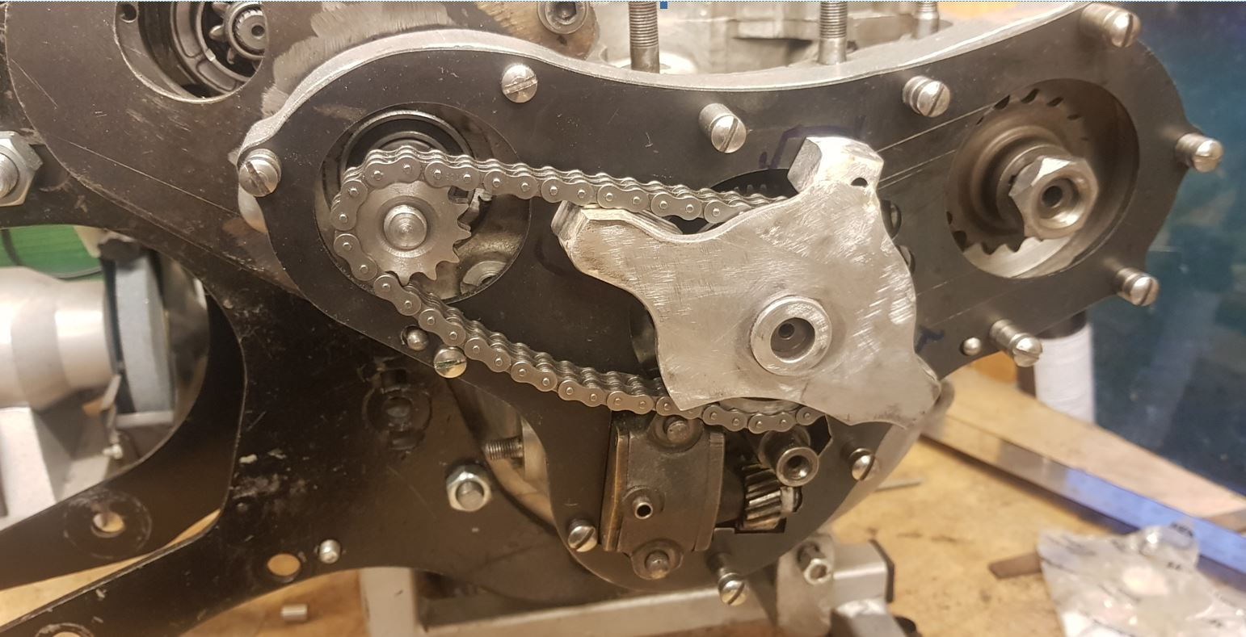
Strengthening Plate with Spider - picking up end of half-time pinion spindle

The result was all had I hoped for visually, and fits the Norton Featherbed aesthetic I reckon.

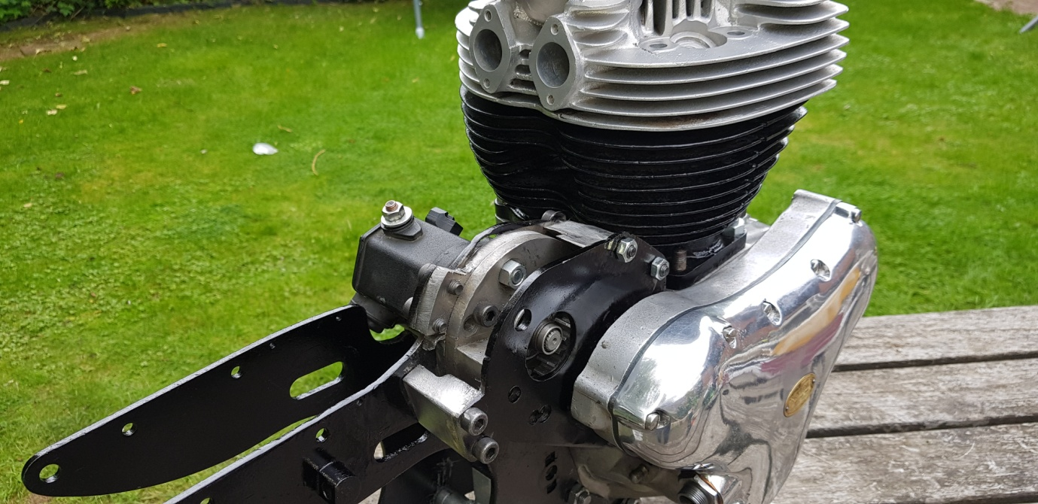
Prototype - with the head added to photographic purposes.
It is a development prototype, so I tested it on full power to see what would break first. Nothing did, but it does go like the clappers! I reckon maybe 800 rpm more or les instantly. As can be seen on youtube.com/watch?v=jRXCE7Ulh1U (between the “U” and the “h” is a lower case “L”).
I guesstimate that only a half or a third of this power will actually be needed for a Dommie. With a small resistance in the circuit it calmed down a lot, but it still spun fast enough to start the engine.
I am going to give the mechanical engineering of a rest now to focus on the power electronics and programming. I need to tame the beast, and to test it properly working against full compression.
But there are plenty of improvements in mind for the mechanics.

*99ES - the rarest of all Dominators, only none were built, of which only two survive.

