The Norton Manxman Story
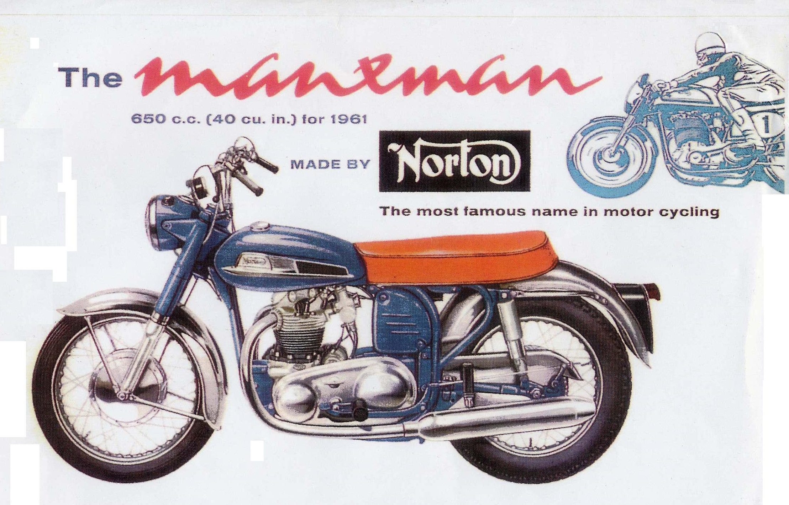
The design of the 650 Dominator engine came about following extensive development work by the Norton Factory in an attempt to build a unit construction twin cylinder engine to compete with the other major British motorcycle manufacturers. This completely new 650cc engine was to be ready for a 1960 launch along with a revised version of Featherbed frame that later came to be called the Slimline.
The Unified Twin ran into manufacturing problems that caused overheating and by the end of 1958 had been shelved in favour of an enlarged version of the 600cc Dominator engine.
AMC boardroom Minutes discretely note the difficulties being faced by the Norton Factory with the Unified Twin and the financial consequences of trying to overcome these. Eventually, time ran out for a practical solution to the engine’s cylinder head issues, so a back-up plan was adopted that involved increasing the stroke of the current Dominator 99 engine plus developing new designs of cylinder head, camshaft and followers. All of these latter items having been previously tested, to some degree in the Nomad off-road bikes that had sold well in many overseas countries.

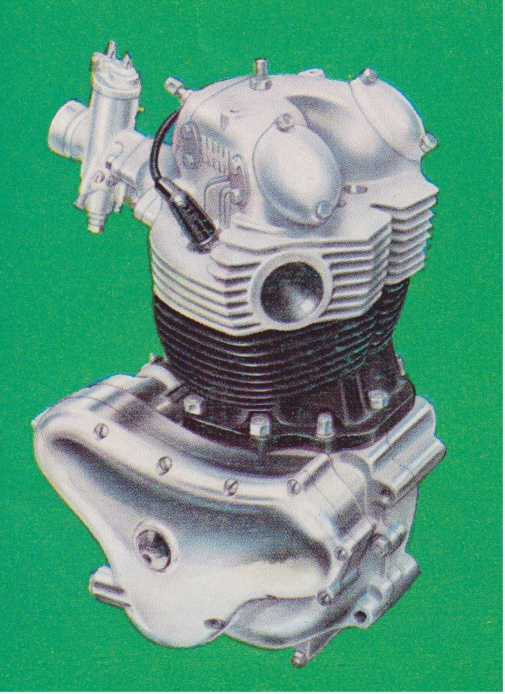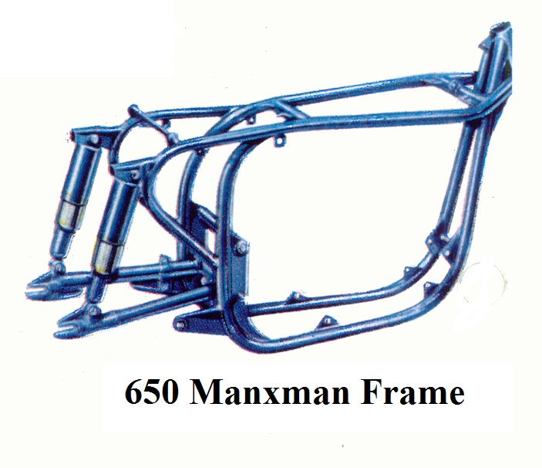

Within just a few months of the ‘go-ahead’ an improved version of the successful QR camshaft, flat foot followers and a revised cylinder head with larger inlet valves and swirl porting were added to the 650-engine design plans. Although the Unified Twin’s problems were eventually sorted it never made it into production. However, work done on its crankshaft led to an increase in the 650 Dominator big-end journal sizes, increasing the diameter of these from 1.50 to 1.75” as a means of adding more strength. The standard Dominator oil pump was given wider internal gearing to increase the feed to the larger journals.
Just as with the Unified Twin, production of the new Dominator engine immediately ran into trouble. With its roots in the design of the old Model 7 500cc engine that gave a modest 29bhp at 6500rpm, the 650 version, from almost day one, was producing nearly double that amount of power. Crankshafts, pistons and barrels all started failing due to the very high output of BHP that the new SS camshaft and improved SS cylinder head were helping to deliver.
Sorting out these problems cost the factory dearly in terms of cash and time. This resulted in a nine month launch delay, curiously echoing the problems experienced in producing the Model 7 machine a decade before. In both cases bike production was halted and the incomplete bikes stockpiled while solutions to the engine problems were sought.

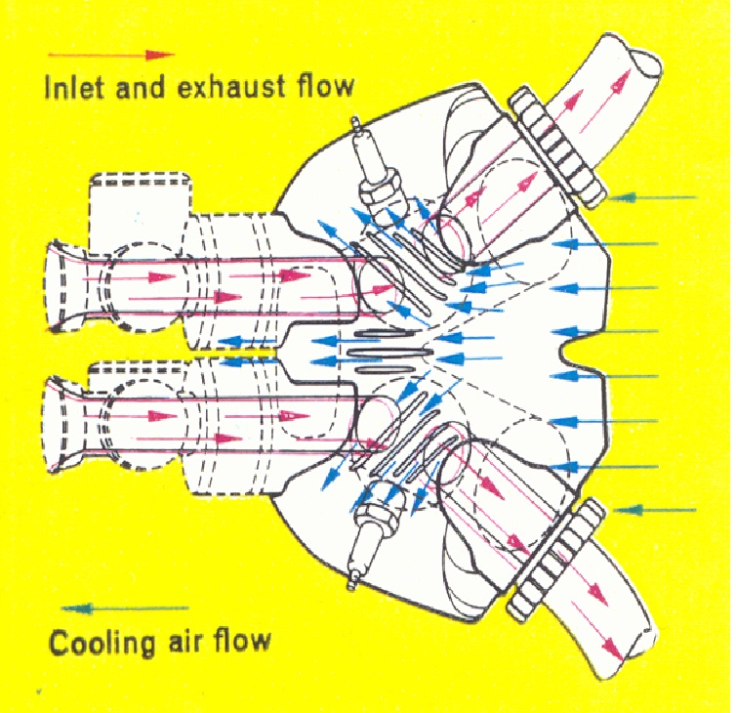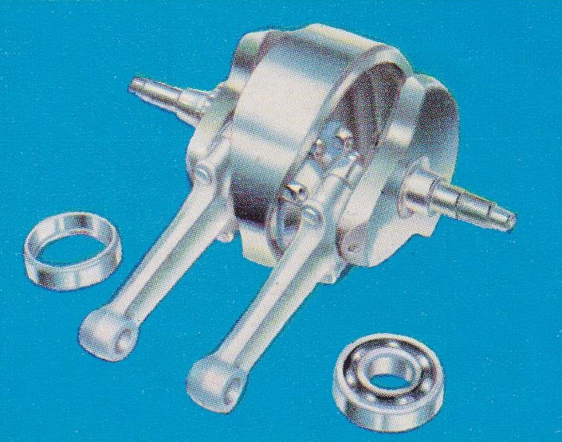

Another unfortunate issue facing the Norton factory, at that time, was a deal set up between the Managing Director, Bert Hopwood and the Berliner Motor Corporation of the USA. This deal gave Joe Berliner exclusive rights to handle the export of all new Nortons heading towards New York and almost any state to the south and east of this city. This included the new 650 model which was yet to be sorted. The delay gave Berliner substantial leverage over the appearance of the first 650 machines and was the major reason the US received one version called the Manxman 650 while the UK and much of the rest of the world got other versions with substantially different styling,
Thus the Norton model as designated by Berliner Corporation to be best suited to the US market, was to have several features that were unique, including its own model name..…The 650 Manxman! The first production runs of the new bikes were exported with unique tanks, exhausts, silencers and handlebars. The majority of the chassis parts being painted Blue with lashings of Chromed items including the primary chain case, mudguards and rear chainguard.
However, the official launch date for the bike came and went as Bracebridge struggled to overcome the fact that all too frequently opening the throttle fully seemed to also push the engine self-destruct button.
Three prototype engines were built during October 1960. Two were completed and used in road bikes with the remaining engine doing bench-testing duties.
Production of road bikes began at the same time with Norton 650 Manxman 93601 18 heading the line but its engine being shop number 7. The second machine 93602 18 had engine shop number 1. Both bikes being shipped on the same day, 7th Novembers 1960. Bike 93603 18 with engine shop number 2 arrived off the production line shortly afterwards.
Of interest here is the production line chronology. The records showing that the first batches of bikes never actually got completed and shipped. Instead these were put into storage for several weeks. Presumably, this was due to shortage of parts to make them roadworthy. A possible reason for this being the design of the very complex, multi-bend exhaust pipes that had only been agreed a few weeks previously and there may have still been a shortage of these components.
The first two Manxman 650 bikes to actually head away from the Factory were 93633 18 and 93637 18. These being shipped on 31 October 1960 with engines 17 and 18. Both of these bikes also heading for the USA.
All the first 50 bikes were sporting a single carburettor as an option to a number of twin carburettor versions that were going to be accompanying them to the same destination. The completed machines then sat around in a warehouse while another 92 bikes were completed as part of the first production run. Then there was a further delay while even more batches of these new machines were produced and also stored.
According to shipping records, no Manxman 650 bikes left the UK until January 1961. The first official shipping date from Liverpool docks being noted as 13th January 1961. With a total of 320 machines having been constructed by the end of 1960.
While the majority of this huge batch were destined for the US market a substantial number were immediately re-shipped to the far corners of the world to promote the arrival of this new Norton model. Sweden, Italy, Belgium, Canada and Australia all getting display models in January 1961. In this batch of bikes, one of the first to be exported to Europe was 94463 18, S/N 141, which headed for the Beng company in Sweden on 24th January 1961.

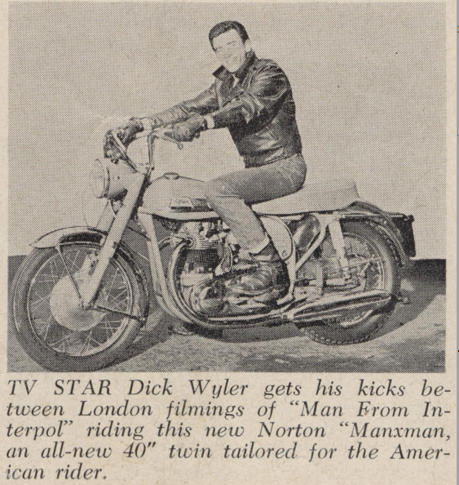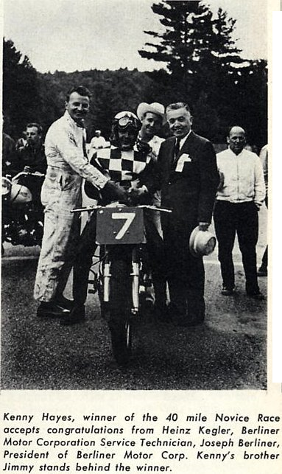

Unfortunately, this is the point in time where confusion and controversy begin to spoil the triumphant start with regard to the history of this machine. While the first 320 machines produced were virtually identical bar the choice of carburettor. Either a single Amal 389 or twin Amal 376s. The batches that followed had significant detail changes including a choice of frame colour of Black or Blue, handlebar heights of raised or semi-raised and seat colour of either Red or Black. An option of a Siamese exhaust system was also available.
The UK launch of the Norton 650SS and other versions was originally planned for October 1961 but politics and financial matters then took control of events away from Bracebridge Street. The AMC Board having decided that future production of all Norton models be moved to their Plumstead, South London Factory.
Meanwhile, model changes were already in the pipeline. An increase in bore size had produced a 750cc engine in response to demands for more ‘cubes’ by the American importers. But echoing the problems of the early Manxman, engine teething troubles led to production delays of this machine as well.
By June 1961 demand in the USA for the 650 Manxman was not hitting the expected targets. Possibly due to rumours regarding the fragility of the engine. Which could fail if it was frequently over-revved. Oil consumption was also a major issue at less than 200 miles per pint. If the oil tank level was not checked on a regular basis it would quickly run dry.
After around 444 Manxman bikes had been built, a change to the oil control ring was made in an attempt to sort out this problem. The Twinflex Piston Ring Company cashing in on their version of quick fix.

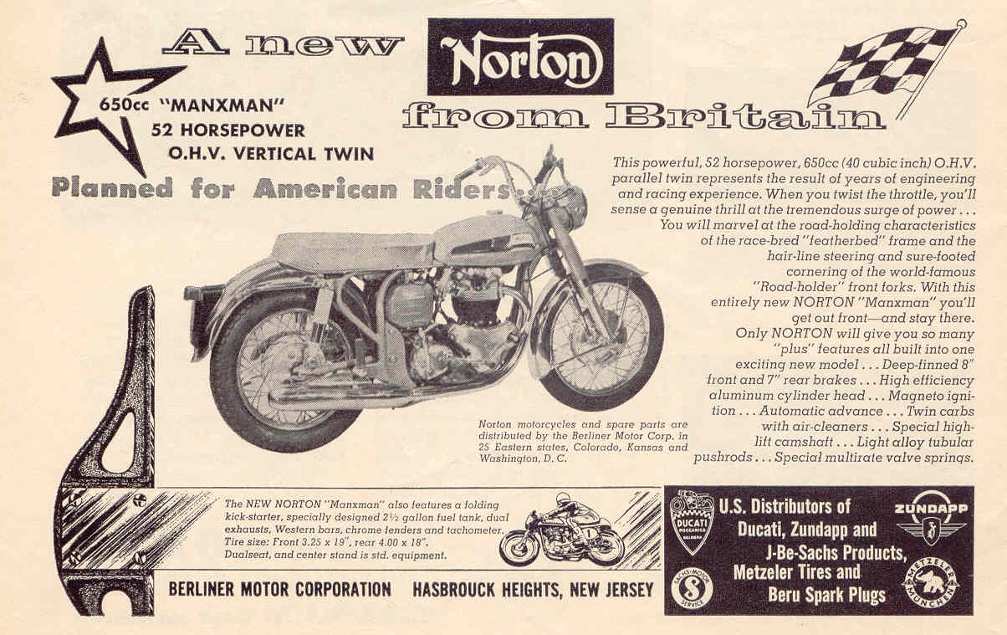

Another 200 Manxman 650s were then built and shipped off to the States but by now consumer demand was beginning to dictate the styling of the model. Consequently, from then on bikes of varied and interesting combinations of trim and model titles appeared in the showrooms.
Some of these bikes had Blue chassis parts. Either a completely Blue tank and chassis and others had a Black frame, Black seat and Blue tank.
At approximately the same time as these bikes were heading west from the UK, the 650SS and De Luxe bikes were beginning to be produced. The first De Luxe recorded is 98739 18D. Some of the early 650ss bikes were painted in the standard European Black and Silver trim but had the small fuel tank and high American style handlebars. The Factory records citing 99498 18 shop engine number 561 as one of the first. Of interest here, the records also state that this particular machine was painted all Blue and not stamped with 650SS. So what actually made it any different from an early Manxman 650? A few lines down in the records is mentioned that all of this batch of 50, bar one were shipped off to Berliner. The exception being 99529 18 shop eng 589 which travelled just 100 miles down the road to Kings of Oxford. Who must have been delighted to get their hands on a genuine 650SS (but not marked 650SS) two months ahead of the official UK launch date.
Thus it was a very odd bunch of 650 Nortons which saw the transition from the American specification 650 Manxman Mk 1, which was all Blue with a Red seat, to the UK standard 650SS colour scheme of all Black with a Silver fuel tank. So although many of the early 650 USA Manxman bikes were certainly to "SS" engine specification, with the SS cylinder head, camshaft and twin carbs, Norton did not stamp their engines with an SS, saving that until the 650ss was formally announced in their advertising sales pitch as a distinctly unique model.

By October 1961, in an attempt to carry over a tenuous link with the original Manxman 650, the new model was renamed and advertised in most US states as the Manxman Mk 2. In Europe and several other parts of the world, this model was still just promoted as the Manxman despite in effect being a 650SS with just a different title and colour schemes. Adding to the confusion for owners restoring bikes from this period was old stock being sold off well into 1962. The result being showrooms selling 650SS bikes with small Silver tanks alongside the new proper 650SS styled bikes with the larger tank but being called the Manxman Mk2. This revised Manxman could have a Red, Silver or Blue 650SS tank, with later style exhaust pipes and silencers. Additionally, some bikes for the European market were painted in the early Mark 1 styling with both a Blue frame and tank, while others turned up with black frames and the choice of Blue, Silver of metallic Red tanks.
From roughly this date onwards, production of the UK Norton 650 switched to three versions of the model. Namely the 650SS, the Standard 650 and the DeLuxe models. This changeover was to have a knock-on effect world wide as numerous people who had ordered a Mk 1 Manxman ended up with the Mk 2 (650SS) version being delivered to them instead.
A further twist of the knife in this respect occurred when owners of early machines tried to order replacement parts for damaged tanks, exhausts and silencers and found that they had to make do with 650SS parts.
So by October 1961 the Mk 1 Manxman 650 was almost history as the Mk 2 version arrived along with the larger engined 750 Mk 1 Atlas. The Factory records indicate that batches of the so-called Manxman Mk2 were sent off to the States and parts of Europe up until February 1965. Often being exported alongside genuine 650SS models.

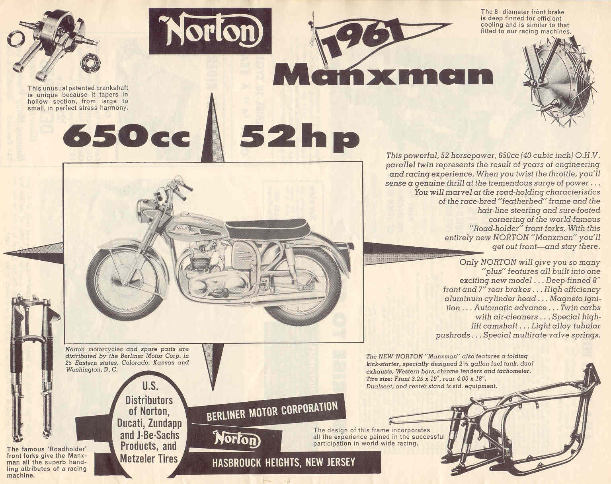

The Finer Details
The factory records list the first Norton 650 off the production line as 93601 18 with a dispatch date of 7th November 1960. However two earlier machines 93633 18 and 93637 18 had been completed and departed on the 30th October 1960. Both were initially used for road testing and after proving the Manxman was a viable product they were given a make-over before being sold on to Berliner.
Two other machines remained in the UK and were registered for road use by Bracebridge. One was later sold to a factory employee and the second to Norton dealer Claude Rye of Fulham.
From the second production batch, 95153 18 was exported to Falkland Islands and 95181 18 went to the City of London Police for trials in February 1961. This bike was fitted with standard 99 chassis parts and painted all black, in essence making it a non-Manxman. It was fitted with high output electrics and probably had an enlarged battery box to take twin 6 volt batteries plus a single seat. At least 3 other Manxman bikes were re-imported back into the UK to private owners that same year.
In May 1961 97931 18 shop number 504 was sold to Redhill Motors Maidstone .
Engine 98738 18 was destined to power a Manxman motorcycle but instead got delivered to Paul Dunstall direct from the Bracebridge experimental department.
99596 18 appears to have been the last official Manxman Mk 1 built.
The Manxman frames were generally stamped at the top of the headstock with a production date such as 12/60/M denoting a bike built in December 1960, with the M standing for Manxman. Engine numbers were stamped on the front left crankcase with the addition of the Model number 18 stamped just after the engine number. These numbers also appearing on the left rear frame gusset plate. The early Manxman engines generally had an engine shop number stamped at the rear next to the breather outlet. Also in this area, would be stamped 65 or 65C Outwardly, the Manxman engine looked very similar to the model 99 motor. The significant external difference being the SS cylinder head with its exhaust ports splayed at 80* and twin horizontal carburettor mountings. The 99 head had narrower 40* angled exhaust ports and vertical mountings for a single carburettor manifold. To get twin carbs on the 99 head involved acquiring a special ‘block’ manifold or making some fancy individual angled manifolds.
The crankcase was almost identical to the previous 88/99 models apart from a built-in bulge near the rear mounting lugs. This was a cheap fix to handle the larger 89mm throw of the 650 crankshaft. Up from the 82mm of the Model 99. On early experimental 650 engines, slots were cut into the crankcase and then welded over to give clearance for the larger conrods.
The central flywheel was also much bigger and the adjoining big end pins were also up in size from 1.50” to 1.75”. The conrods did not have the small end bushes of the earlier twins and the first version still used Aluminium caps to hold the shells. This latter item was quickly changed to steel in an attempt to prolong the life of the bottom end.

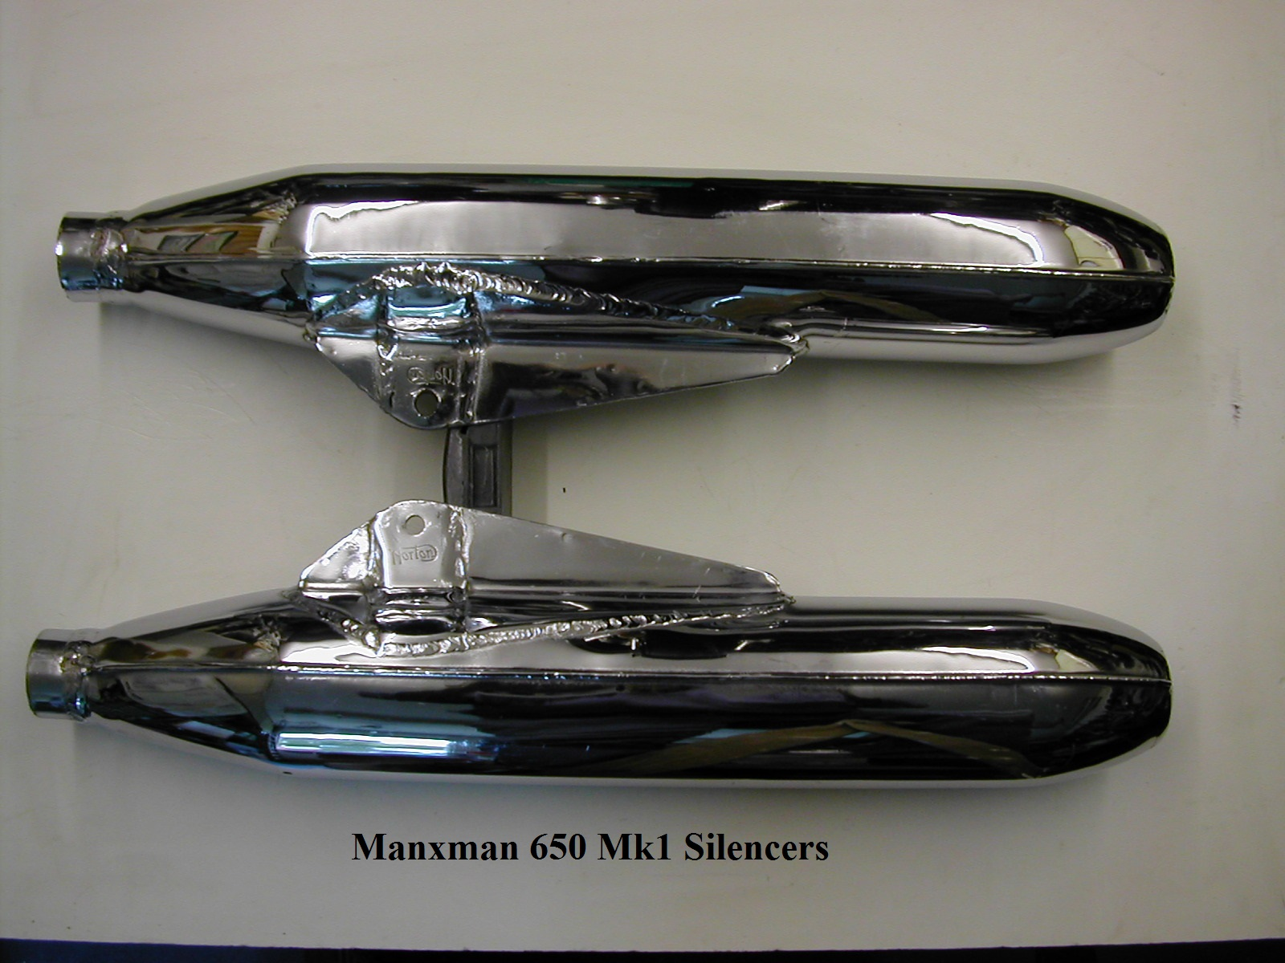

The introduction of the SS cylinder head gave problems with the run of the exhaust pipes down to the silencers. Causing them to stand further away from the engine, than those of the Model 99. This in turn leading to problems of fouling the brake lever, kick-start lever and rev counter drive cable. The solution on the Manxman was to add extra bends immediately after exiting the cylinder head in order to bring the run back closer to the frame downtubes. This helped to tuck the left-hand pipe nearly under the primary chaincase alternator cover and the right-hand pipe under the timing cover. Unfortunately, manufacturing these pipes was time consuming and expensive and they were quickly superseded by waisted pipes minus the extra bends. The Manxman Mk 1 had equally unique silencers that no UK after-market maker has bothered attempting to reproduce. Like the exhaust pipes, finding unused examples of these silencers would equate to winning a Lotto Million.
Just over 600 Manxman bikes were produced which fall into the Mk 1 category of early style tank, exhausts, silencers and colour scheme. By October 1961, the official 650SS had arrived and headed the number 1 spot.
Berliner got the only spare parts list produced and there is little mention of Manxman parts in the UK spares lists of 1961/2. This parts book is a bit of a joke as the so-called 650 diagram, in the front, is actually a 1955 Model 88 engine with a few revisions. Both the cylinder head and barrel shown are clearly off a pre-1957 Model 88.

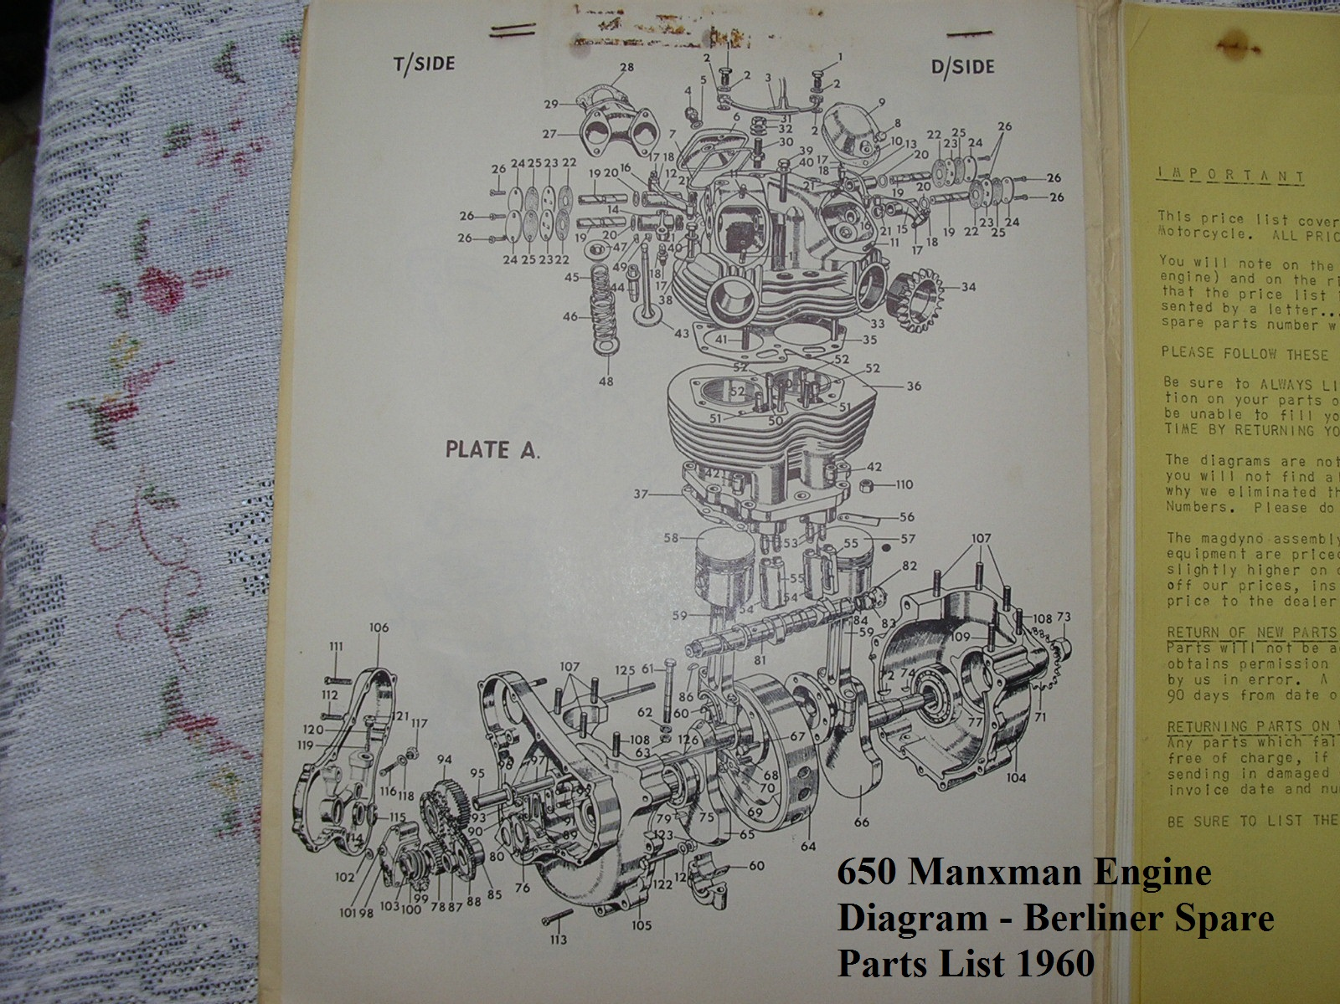

Value for Money
So what did owners of the new Manxman get for their hard earned dollars?
Bore: 68mm - Stroke: 89mm
Compression Ratio: 8.25 to 1.
Gearbox before 1962: AMC 1 type.
Gas/Petrol Tank: 2½ Gallons. Some European models sold with larger 3.65 Gallon tanks.
Oil Tank Capacity: 4.5 Pints.
Ignition: Lucas K2FC Magneto
Carburettors: Single Amal Monobloc 389 or Twin Amal Monobloc 376
Wheels/Tyres: Front 19 x 3.25 Dunlop Ribbed ; Rear 18 x 4.00. Dunlop K70.
Some European models fitted with 19” rims and 19” x 3.50 Avon tyres.
Tinware Chromed Mudguards, Primary Chaincase and Rear Chain Guard. European models had these parts painted with Chrome as an option.
Rear chains: ⅝ x ¼. – 98 links.
Sprockets: Engine 21 teeth. Gearbox 19 teeth. Rear wheel 43 teeth.
Ignition Timing: 32* BTDC (8.69mm on standard pistons)
Tappet/Valve clearance: – 0.006” inlet; 0.008” exhaust
Looks:- Blue Fuel Tank, Frame, Headlamp Shell, Fork Shrouds, Battery Box and Oil Tank, Raised Handlebars.
Instruments:- Headlamp mounted Smiths Chronometric Speedometer, Fork mounted Smiths Chronometric. Rev Counter.
Kerb Weight: Dry 425lbs
Options: Rev counter, Two into one exhaust system. Some models were exported with the folding kick-start, rear footrests, and some of the Chromed tinware as optional.,

Summary
Those readers that have managed to get this far will appreciate what started as a simple straightforward story about a single Norton model rapidly degenerated into a confused mix of facts, figures and descriptions. Unfortunately, this became typical of the factory sales policy from then on with badge engineering and model mixing becoming the norm in order to generate bike sales and income.
Condensing the story down to its basic chronology we should have…….

October 1960 – Two road-running prototypes with un-numbered engined built.
November 1960 – First batches of export models built and stored. Painted all Blue.
January 1961 – 318 bikes shipped worldwide. First 100 to Tozer, Berliner in New York. Second consignment for Europe, Canada, Far East and Australia (via Berliner). Some heading off immediately to other countries as showroom promotion models.
April 1961 – Third major consignment assembled. A good number of these having black frames and black seats.
May 1961: Small numbers of 650 bikes released onto UK market. 93971 18 E/N 504 goes to Redhill Motors in Surrey and 99529 18 to Kings of Oxford.
September 1961 – Official launch of 650SS in UK. With Black frame and Silver tank. In the USA these are often called the Manxman Mk 2 while in Europe and around the rest of the world many of these bikes are promoted as the just the Manxman. Many exported models are in 650SS trim but painted in either all Blue, or Black frames with Blue, Silver or Red tanks. In the USA some 650SS bikes are sold with the smaller Manxman 2 1/2 gallon tank painted in Silver.
Exhaust pipes changed to 1 3/8” diameter, part number 24020 & 24021. These had less bends and ran further away from the timing and alternator covers. Earlier 23432 & 23433 1 5/8” pipes still available for a while.
September 1965 – Final official batch of Manxman Mk2 bikes built and shipped to USA. All with Black frames and Red tanks.
Total production of all Bikes with a Manxman label dangling from the handlebar appears to be around 2000 but of these only about 600 fulfil the Manxman Mk 1 specification criteria.

Phil Hannam
Norton Owners Club

