1962 Navigator Standard in Dove Grey and Blue

Items to be powder coated in Dove Grey (RAL1013)

Frame parts assembled with spacers. No masking on required.
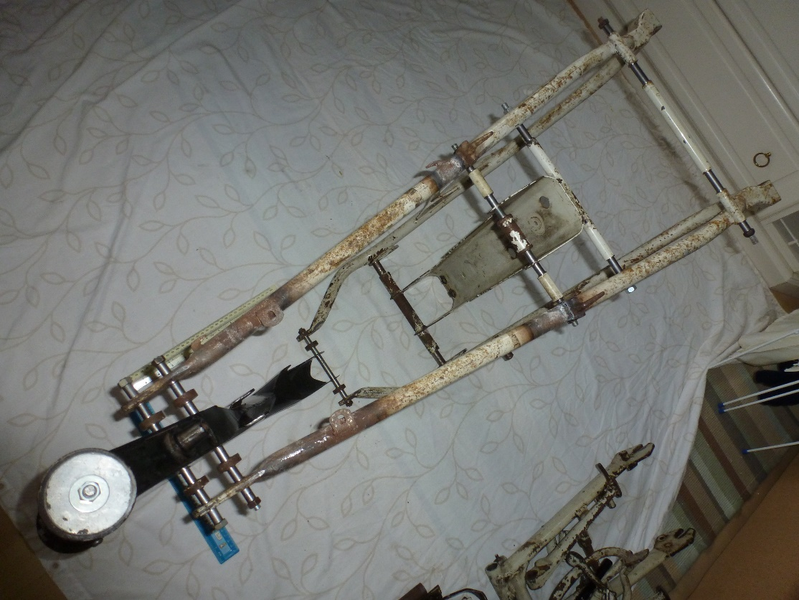
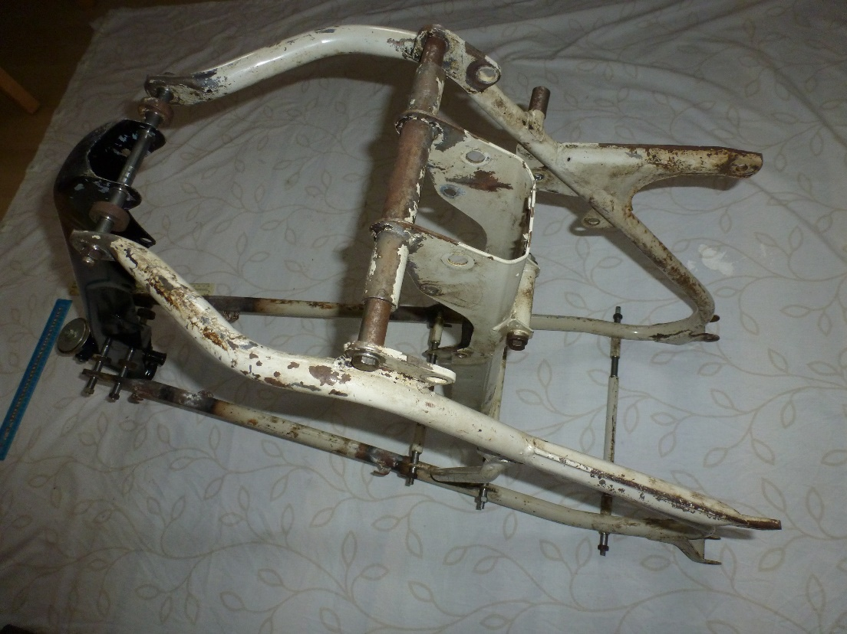
Tube covers brake pivot pin.

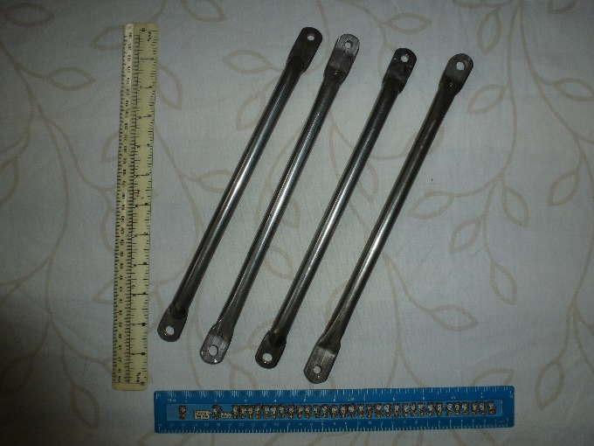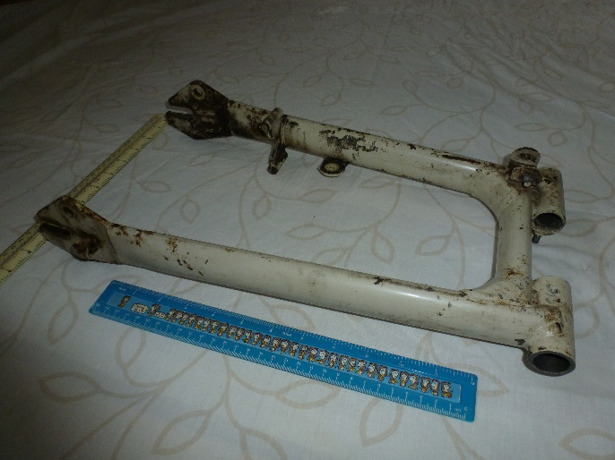
Front mudguard stays (4) Swinging arm. Mask holes for bushes(2), Threads for wheel adjustment (2), and threads for chainguard (3)
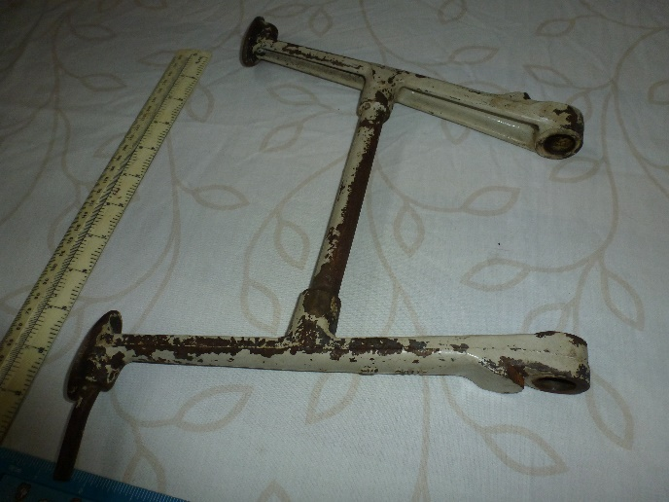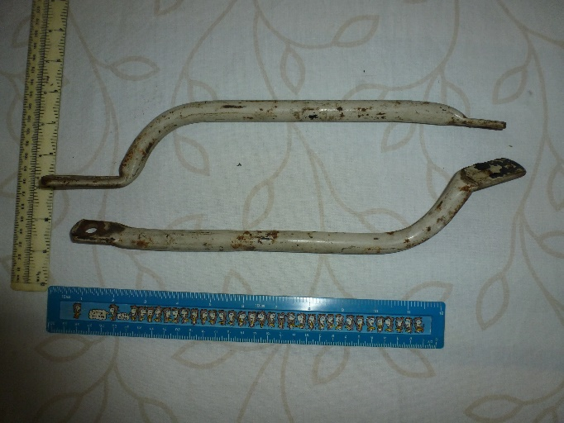
Centre stand Rear Mudguard stays
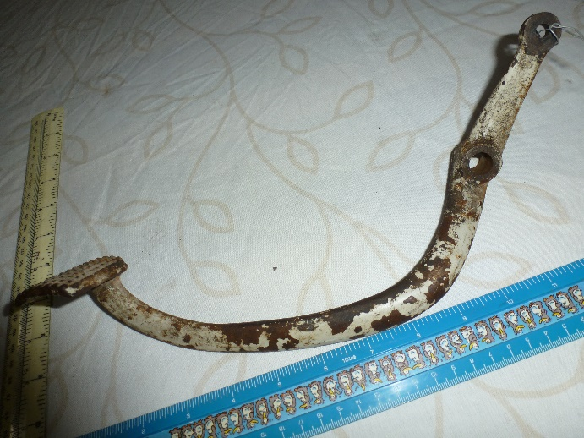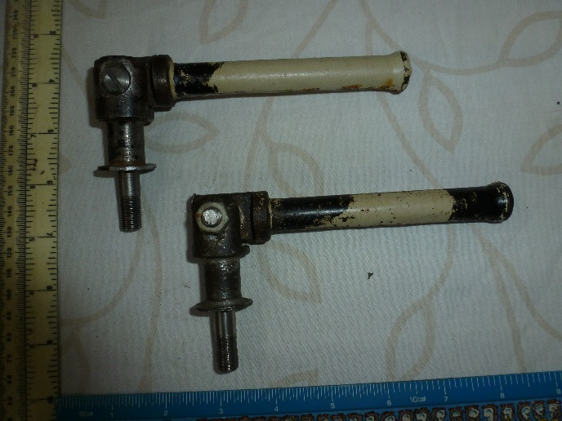
Brake Pedal Pillion footrest assemblies. Paint in folded position. Mask mounting studs and threads.

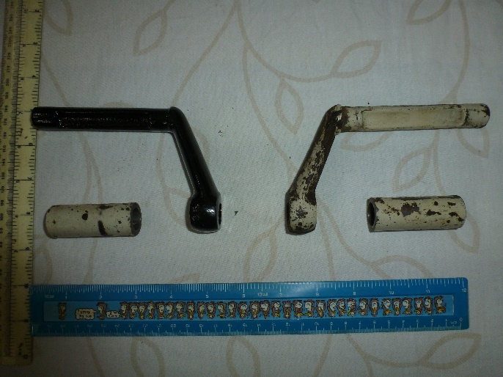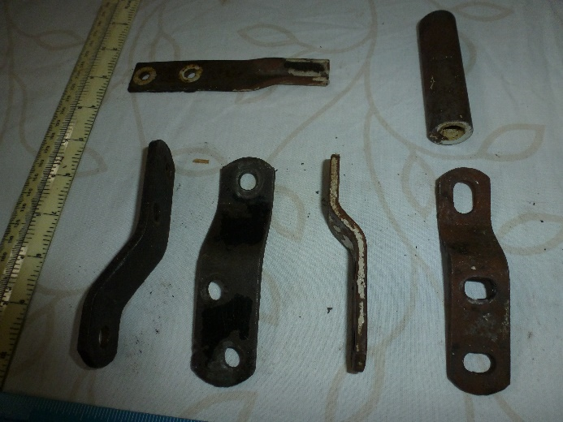
Footrests (2) and spacers (2) Exhaust hangers (4) spacer and stand stop bracket

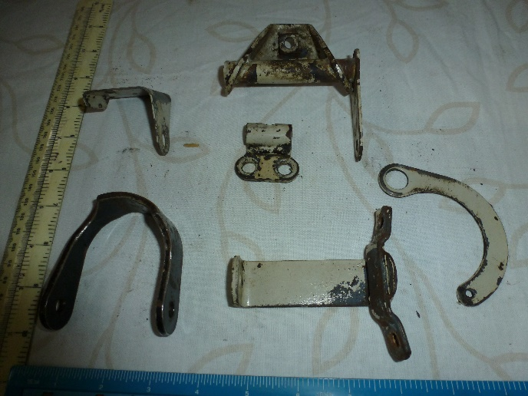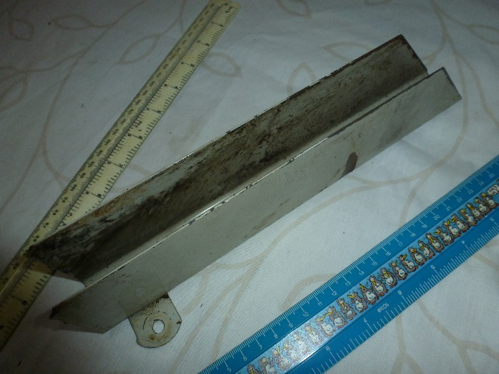
Brackets Misc (6) Chainguard lower

