Wheels, Rims & Tyres
The Norton Dominators used both Jones and Dunlop rims across the range of models from 1948 to 1970. With the exception of the early models and some of the export hybrids, these rims were all WM2 in width.
The WM size and rim diameter being stamped on the least curved portion of the inner side of the rim.

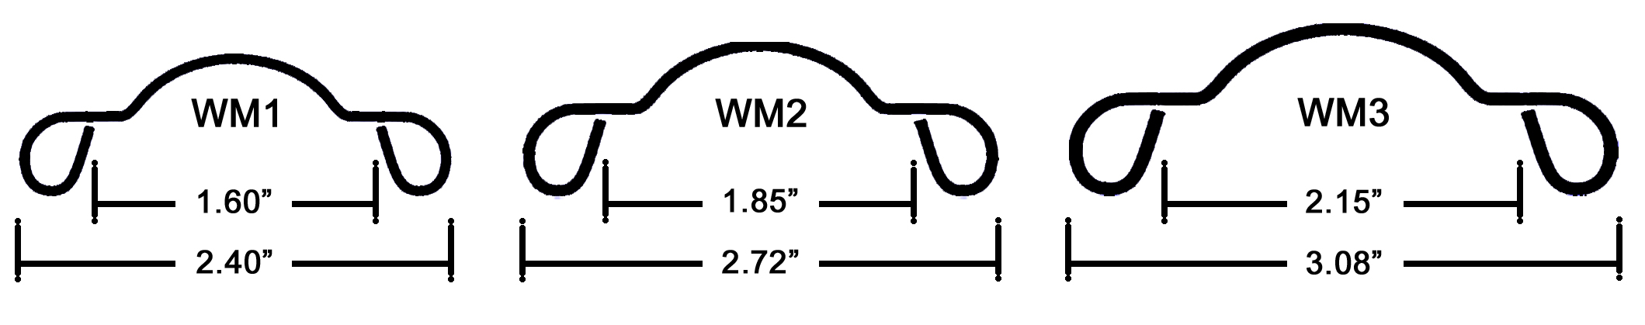

The original 1948 promotional poster for the Model 7, lists the tyres as Dunlop Ribbed front and Dunlop Triple Stud rear. Subsequent Norton Models Catalogues document the tyre/rim sizes, but not the tyre manufacturer.
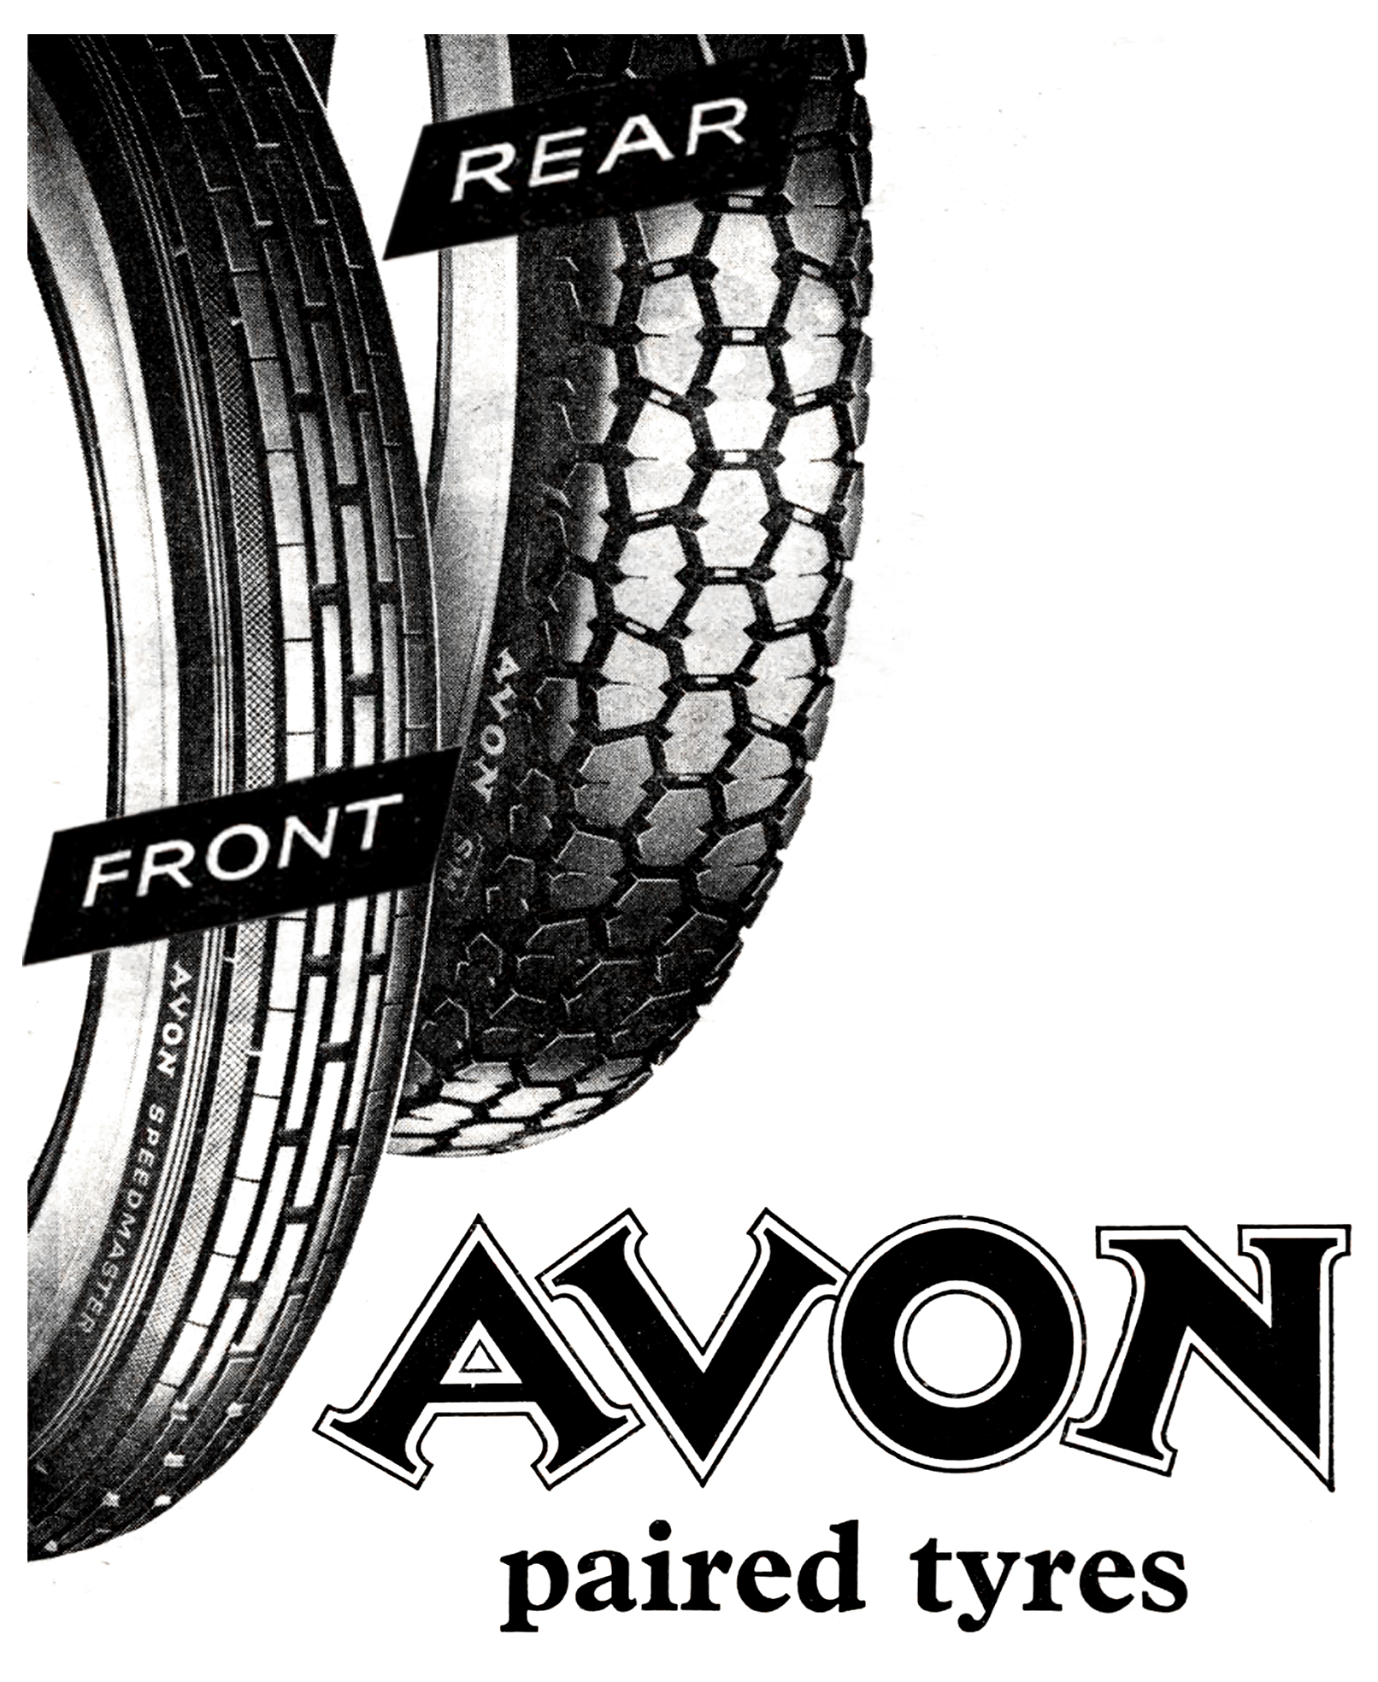

On the fly-leaf of the Norton Motors Record Book No. 13
is the following notation:
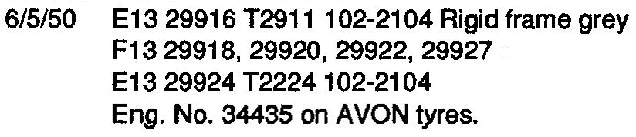

The choice of tyres now falls into three
broad categories:

Original, Period ‘Sporty’ and Modern.

Original: The brand of tyres originally fitted by
by Norton from 1948 into the 1960s, were
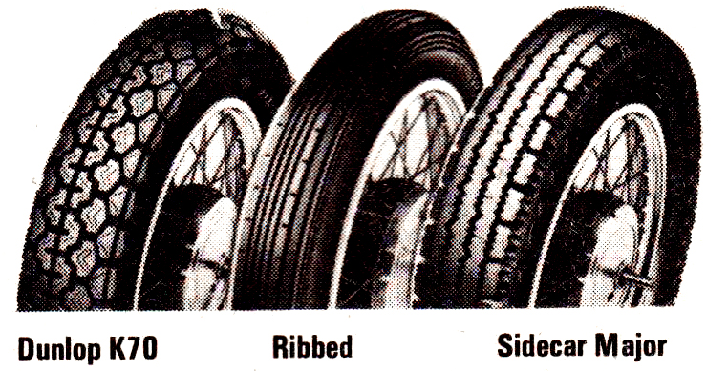
either Dunlop or Avon.

The Dunlop tyres were K70 Universal,
Ribbed, and Sidecar Major.

The Avon tyres were Speedmaster Ribbed,
Safety Mileage (SM) and Universal Sidecar.

The term Universal usually refers to a tyre
suited to either front or rear fitment.

Period ‘Sporty’: The tyres listed above continued as standard fitments or options until the late 60s saw the arrival of the Racing compound Avon GP, followed by the Dunlop TT100 (K81) and Avon Roadrunner. There were other continental options available but generally because in time, Norton standardised on WM2 x 19” rims (Export 18” on the Manxman 650 and Atlas), the choice was very limited when trying to get a matching front and rear pairing. For the off-road bikes both Dunlop and Avon both produced a range of heavy-duty ‘knobbly’ tyre.

