Electra (& Navigator Forks)
Stanchion – P. No. 18482

NOC Spares:
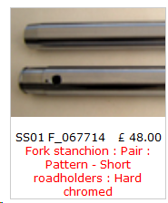

=========================================
Andover Norton:

