Dominator Timing Covers - Restoration & Running
Check that the mating faces are flat and free of dings or dents. Minor blemishes can be dressed out but you may need to remove the location pins to do this. If you have a cover that does not have a set of location pins then get some made and fitted. Otherwise there is a risk of the cover slipping down enough to pull over the intermediate Spindle and mess up the gear meshing.
The intermediate spindle should be a sliding fit in the timing crankcase. If it is a little sloppy this will be reasonably acceptable as the cover will hold it in place but not necessarily prevent it from turning. Some bearing fit can be of help to prevent the spindle rotating but when re-assembling, do make sure that the drain hole in the spindle centre is facing downwards.
Generally the Intermediate spindle does not wear that quickly whereas the bush in the intermediate gear does. Check both and change if need be.
Both versions of the Pressure Release valve are relatively easy to remove and dismantle for examination. Use lots of heat to warm up the obvious areas before applying spanners or sockets on the valve end nuts.
The external version, as shown below, will usually comes apart but leave the valve stuck up inside the cylinder. Some creative thinking may be required to remove it. Air hose, magnet, sucker!!!
There may be up to 5 shims inside the piston. These were used by the factory to help set the true release value which should be between 45 and 55 psi. The spring needs to be 1.171” in length.
Unless some special gear is available to specifically check the settings of these valves the only other method of checking (for most owners) is to plumb in a pressure gauge to the oil feed system.
As these springs are very cheap, it makes sense to buy and fit a new one. A spring that has gone weak will lower the pressure to the crankshaft allow the timing cover to get flooded with excess oil. Get the new spring from a reputable dealer, as these should be made to a specification that allows fitting without the piston shims. Ask for part number 067544.
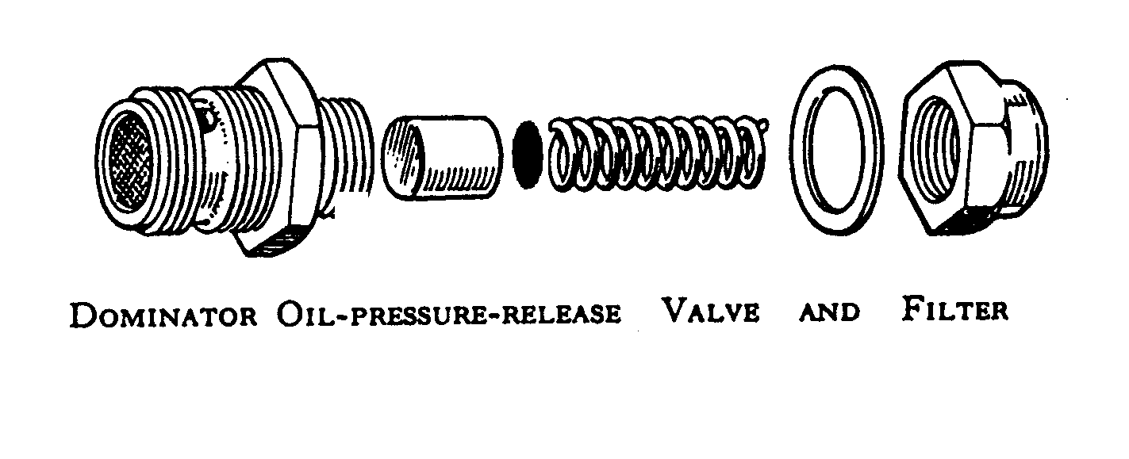
The internal Pressure Release Valve has two separate sections to it. See diagram below.

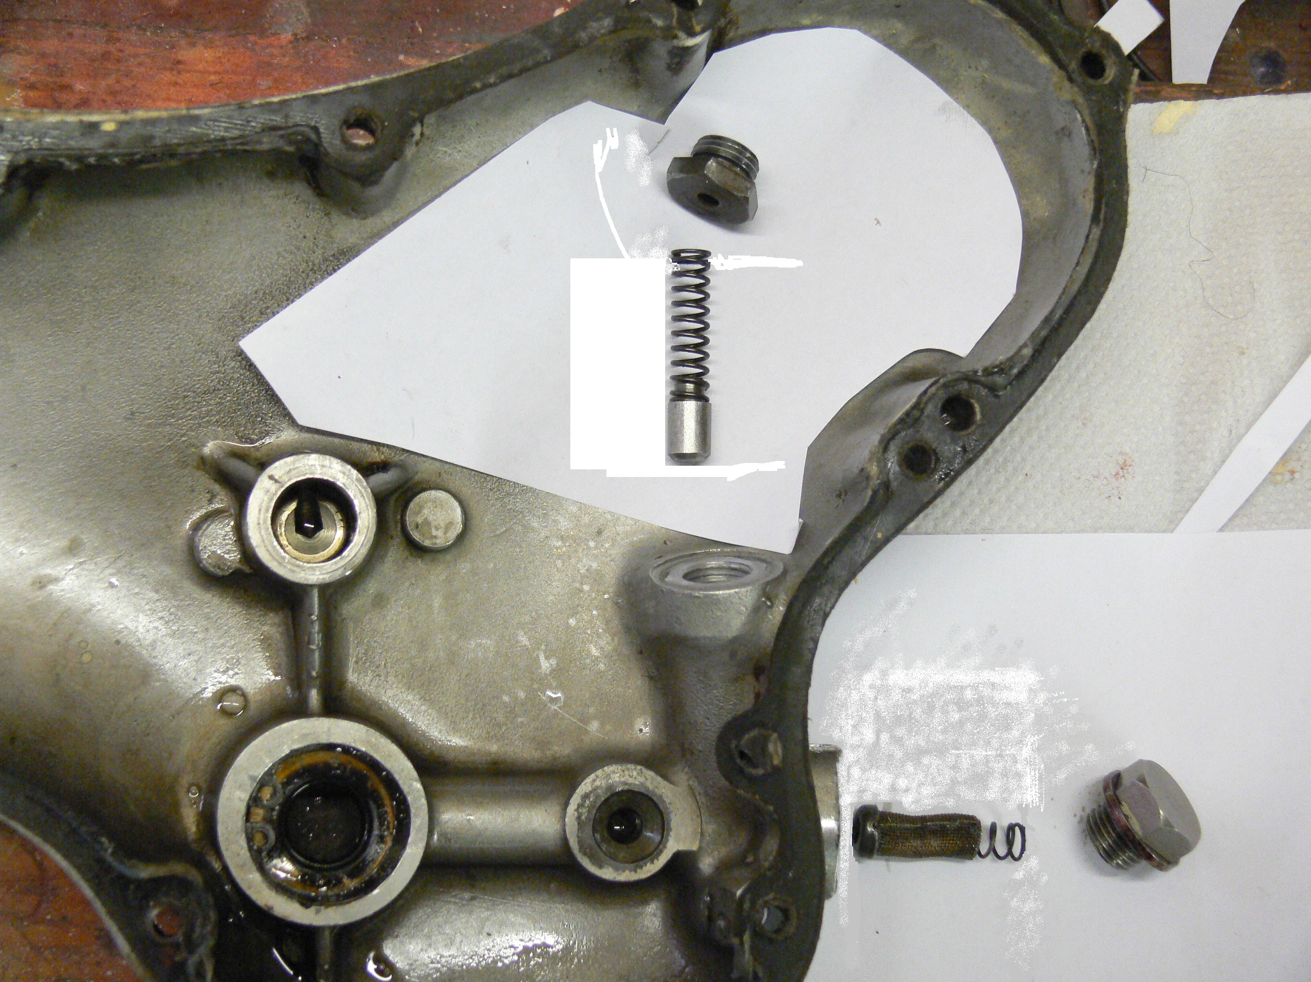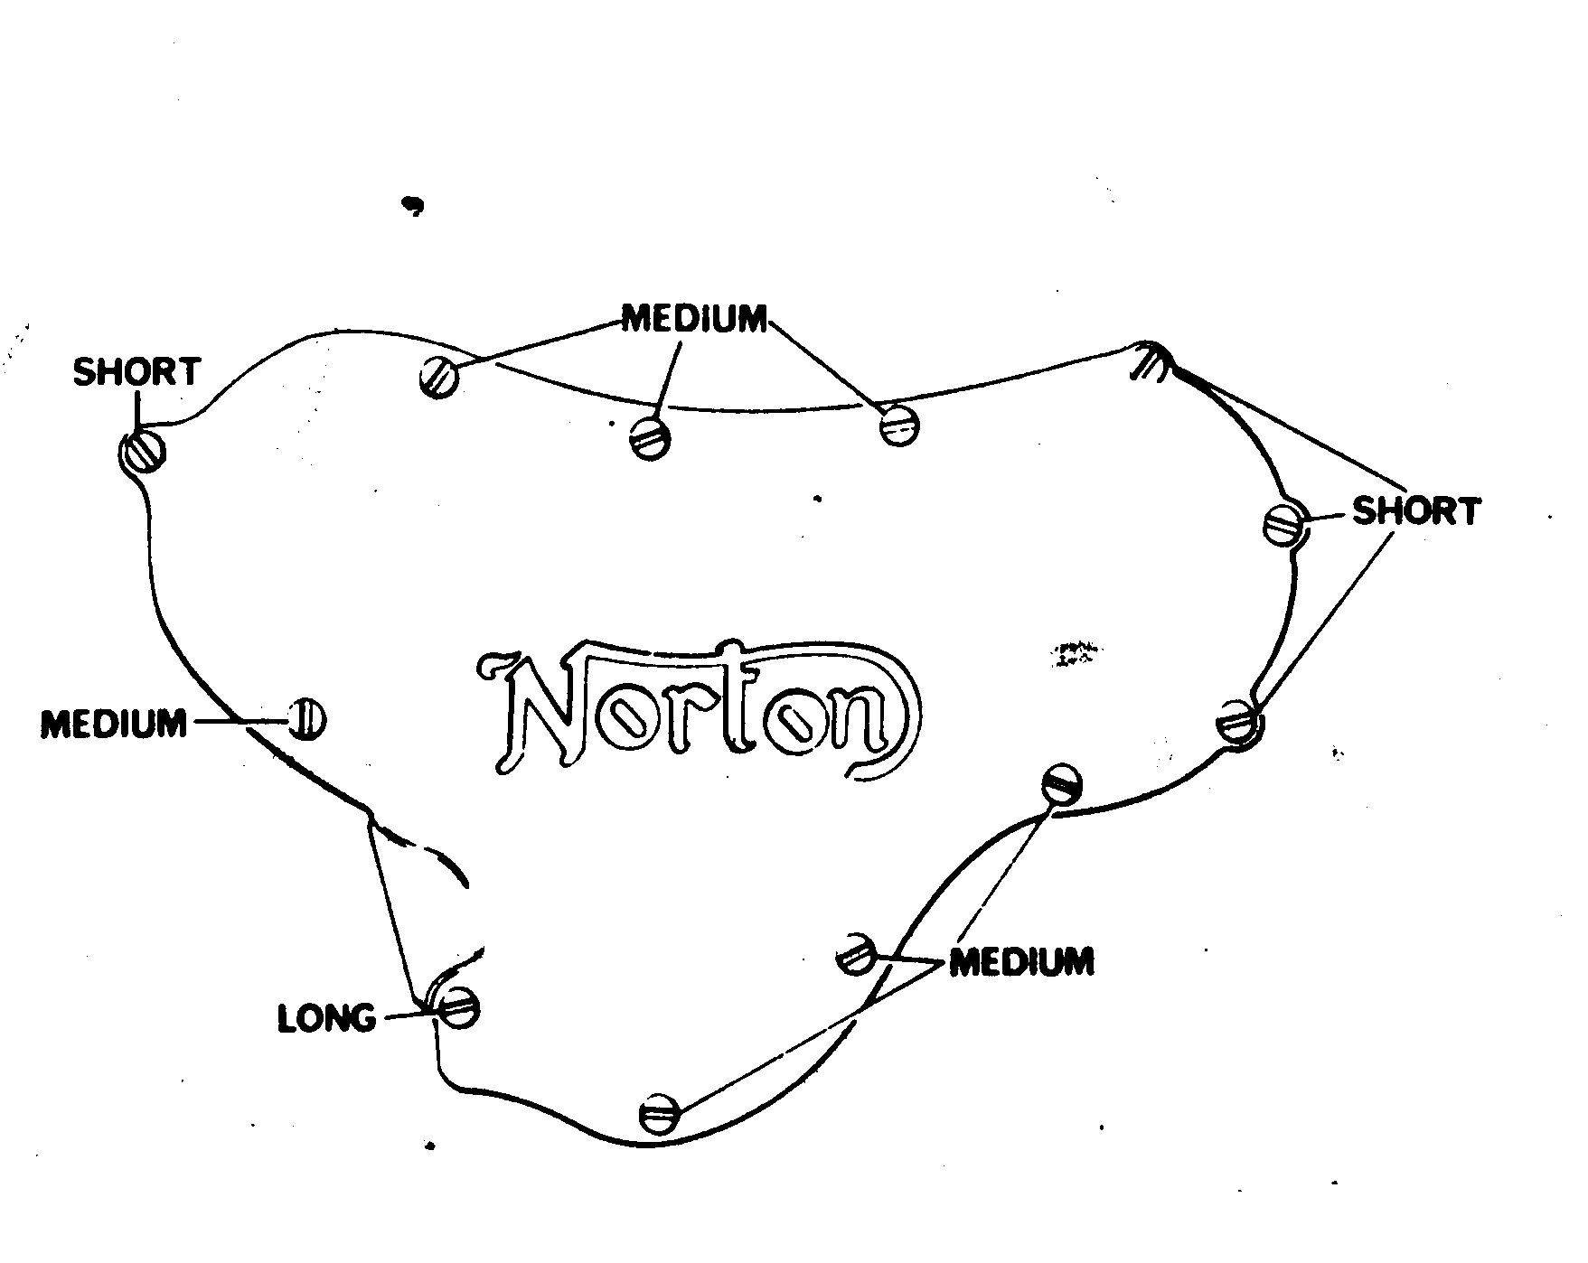

This generally was fitted to covers in the 1958 to 1961 period. In this cover there are two springs to check though the lower one is just to hold the filter in place.
The sizes of the valve operating springs in this cover are different in length and sit on the valve end rather than inside it. Part number for this spring is 020286.
The early timing covers had three sizes of screw to hold it in place. All were ¼” BSF threads.
Most of the replacement sets available generally offer a ‘two size’ kit. These screws need to go in the correct holes or they will not do a proper job. Check the diagram above right.

