[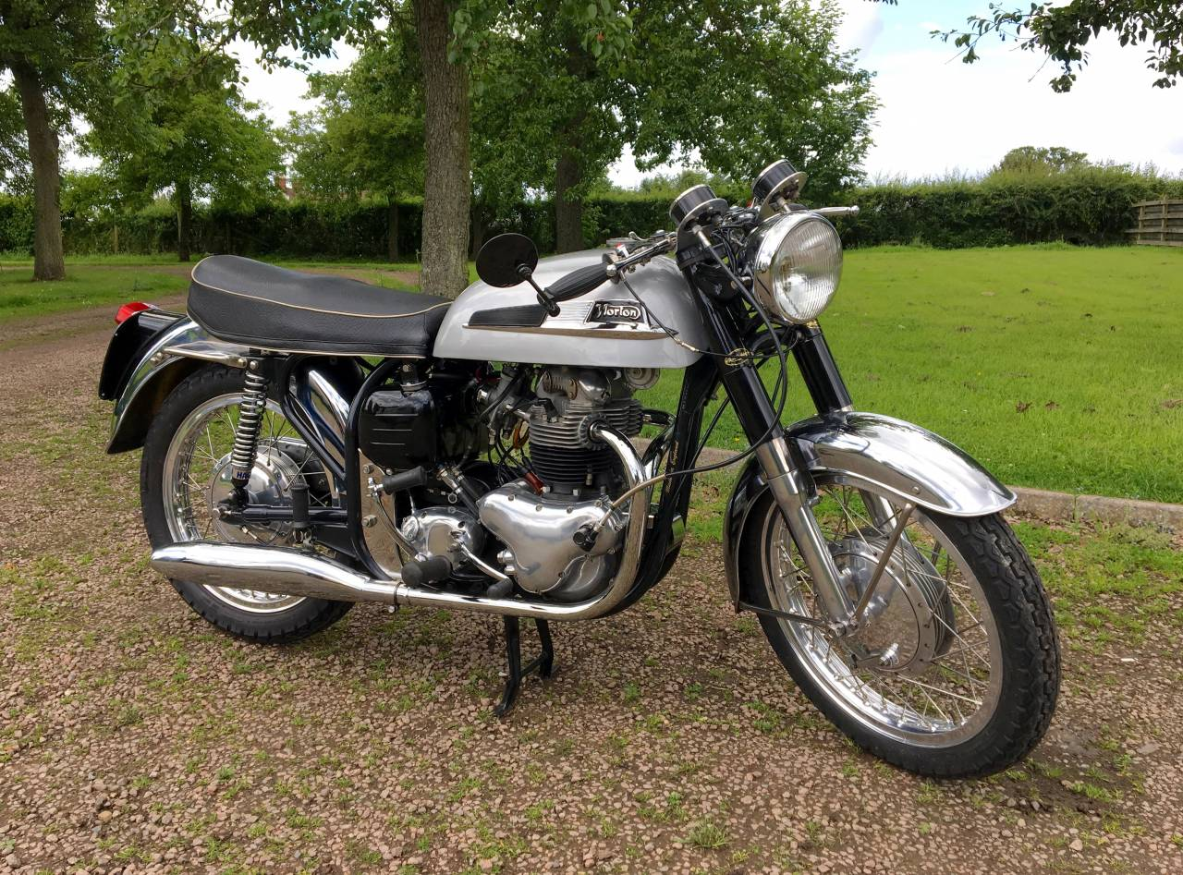](https://wesellclassicbikes.co.uk/img/bikes/large/915926.jpg)

**1962 Norton 88SS**

[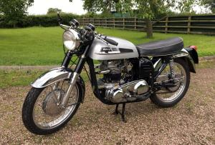](https://wesellclassicbikes.co.uk/img/bikes/large/703391.jpg)[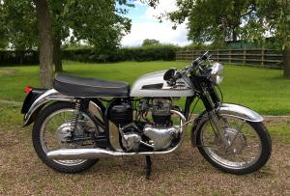](https://wesellclassicbikes.co.uk/img/bikes/large/472489.jpg)[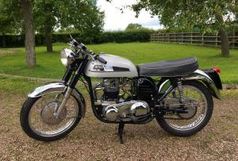](https://wesellclassicbikes.co.uk/img/bikes/large/968350.jpg)[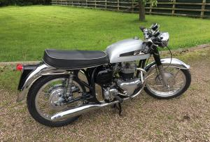](https://wesellclassicbikes.co.uk/img/bikes/large/310030.jpg)[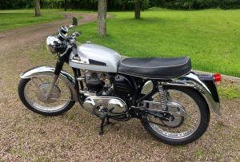](https://wesellclassicbikes.co.uk/img/bikes/large/906603.jpg)[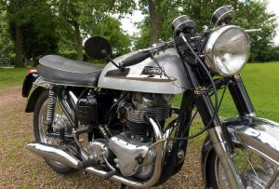](https://wesellclassicbikes.co.uk/img/bikes/large/351471.jpg)[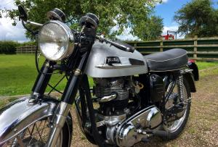](https://wesellclassicbikes.co.uk/img/bikes/large/302187.jpg)[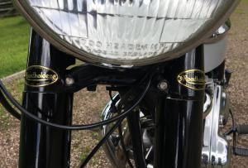](https://wesellclassicbikes.co.uk/img/bikes/large/566209.jpg)[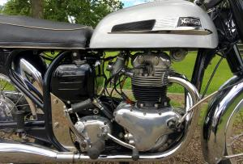](https://wesellclassicbikes.co.uk/img/bikes/large/764624.jpg)[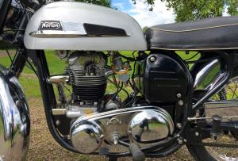](https://wesellclassicbikes.co.uk/img/bikes/large/458421.jpg)[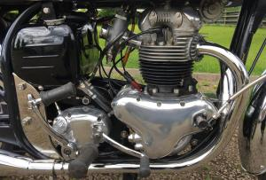](https://wesellclassicbikes.co.uk/img/bikes/large/732060.jpg)[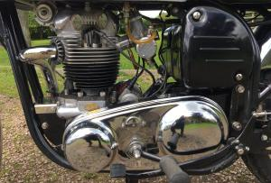](https://wesellclassicbikes.co.uk/img/bikes/large/752248.jpg)[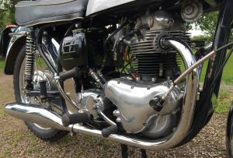](https://wesellclassicbikes.co.uk/img/bikes/large/757805.jpg)[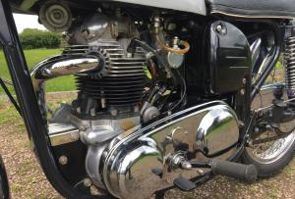](https://wesellclassicbikes.co.uk/img/bikes/large/861397.jpg)[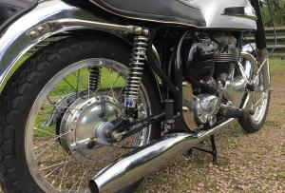](https://wesellclassicbikes.co.uk/img/bikes/large/605315.jpg)[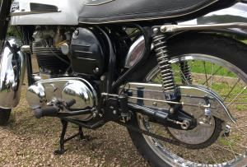](https://wesellclassicbikes.co.uk/img/bikes/large/402911.jpg)[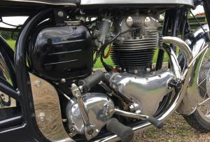](https://wesellclassicbikes.co.uk/img/bikes/large/336137.jpg)[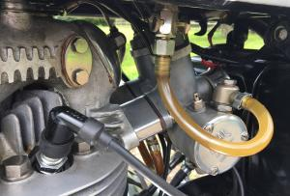](https://wesellclassicbikes.co.uk/img/bikes/large/911401.jpg)[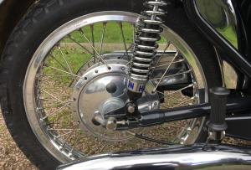](https://wesellclassicbikes.co.uk/img/bikes/large/281531.jpg)[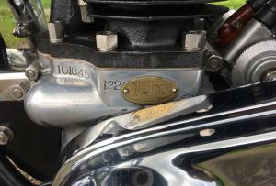](https://wesellclassicbikes.co.uk/img/bikes/large/623484.jpg)[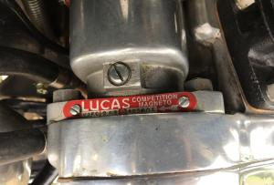](https://wesellclassicbikes.co.uk/img/bikes/large/616926.jpg)[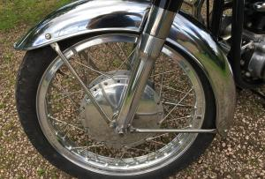](https://wesellclassicbikes.co.uk/img/bikes/large/242641.jpg)[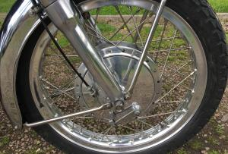](https://wesellclassicbikes.co.uk/img/bikes/large/275012.jpg)[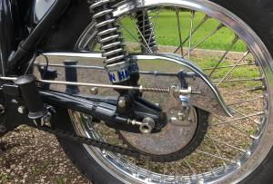](https://wesellclassicbikes.co.uk/img/bikes/large/552105.jpg)[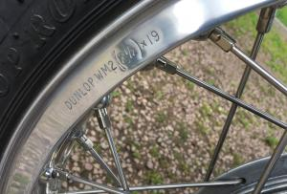](https://wesellclassicbikes.co.uk/img/bikes/large/942856.jpg)[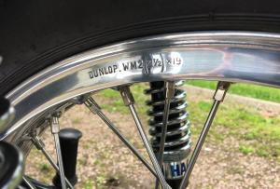](https://wesellclassicbikes.co.uk/img/bikes/large/856035.jpg)[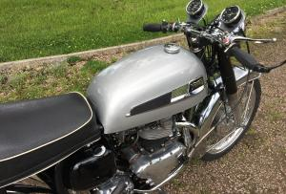](https://wesellclassicbikes.co.uk/img/bikes/large/814083.jpg)[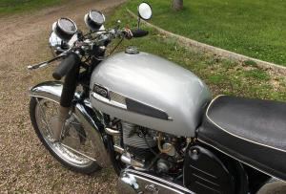](https://wesellclassicbikes.co.uk/img/bikes/large/415777.jpg)[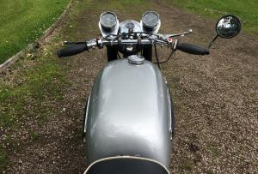](https://wesellclassicbikes.co.uk/img/bikes/large/549070.jpg)[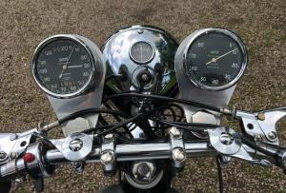](https://wesellclassicbikes.co.uk/img/bikes/large/703287.jpg)[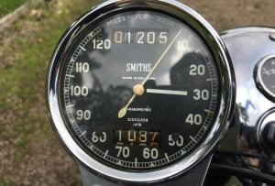](https://wesellclassicbikes.co.uk/img/bikes/large/885902.jpg)

Bottom of Form