

From <https://jsmotorsport.com/shop/>

See 🡪 https://jsmotorsport.com/js-motorsport-videos/

See 🡪 Norton head building. Video

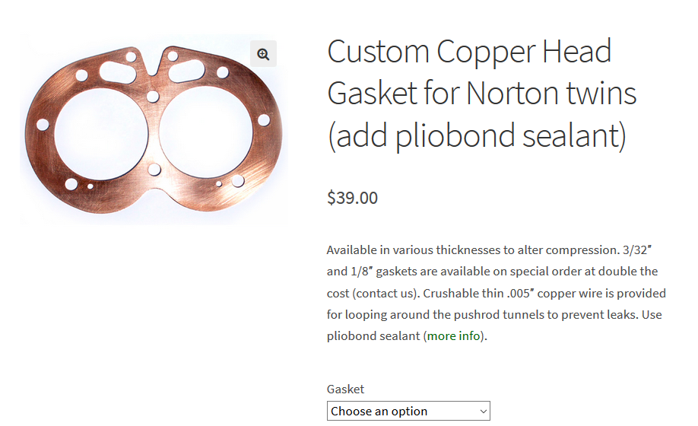

Pliobond used with Cu Head Gaskets and .005 wire

